**LAB CYCLE:1**

**EXPERIMENT NO:1**

**Date:**

**Aim:** Familiarisation with computer hardware.

Introduction to Computer hardware: Physical identification of major components of a

computer system such as mother board, RAM modules, daughter cards, bus slots, SMPS,

internal storage devices, interfacing ports. Specifications of desktop and server class

computers. Installation of common operating systems for desktop and server use.

**Description:**

1. **Introduction to Computer hardware**

Components of a computer system are the primary elements which make the functioning of an electronic device smooth and faster. Computer systems consist of three components as shown in below image: **Central Processing Unit, Input devices and Output devices**. Input devices provide data input to processor, which processes data and generates useful information that’s displayed to the user through output devices. This is stored in computer’s memory.

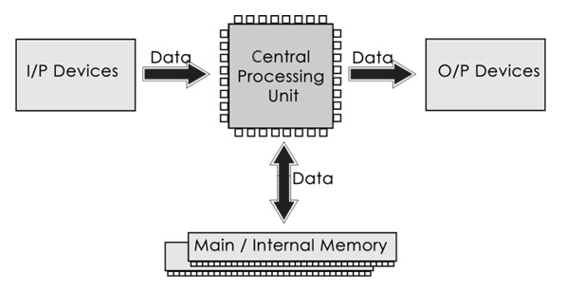

The operations of computer components are given below:

**1) Inputting:** It is the process of entering raw data, instructions and information into the computer. It is performed with the help of input devices.

**2) Storing:** The computer has primary memory and secondary storage to store data and instructions. It stores the data before sending it to CPU for processing and also stores the processed data before displaying it as output.

**3) Processing:** It is the process of converting the raw data into useful information. This process is performed by the CPU of the computer. It takes the raw data from storage, processes it and then sends back the processed data to storage.

**4) Outputting:** It is the process of presenting the processed data through output devices like monitor, printer and speakers.

**5) Controlling:** This operation is performed by the control unit that is part of CPU. The control unit ensures that all basic operations are executed in a right manner and sequence.

**Central Processing Unit (CPU)**

A Central Processing Unit is also called a processor, central processor, or microprocessor. It carries out all the important functions of a computer. It receives instructions from both the hardware and active software and produces output accordingly. It stores all important programs like operating systems and application software. CPU also helps Input and output devices to communicate with each other. Owing to these features of CPU, it is often referred to as the brain of the computer.

CPU has three components:

* ALU (Arithmetic Logic Unit)
* Control Unit
* Memory or Storage Unit

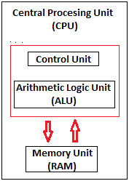

**b)** **Physical identification of major components**

Hardware, which is abbreviated as HW, refers to all physical components of a computer system, including the devices connected to it. You cannot create a computer or use software without using hardware. The screen on which you are reading this information is also a hardware

**1. Motherboard:** The motherboard is generally a thin circuit board that holds together almost all parts of a computer except input and output devices. All crucial hardware like CPU, memory, hard drive, and ports for input and output devices are located on the motherboard. It is the biggest circuit board in a computer chassis. It allocates power to all hardware located on it and enables them to communicate with each other. It is meant to hold the computer's microprocessor chip and let other components connect to it. Each component that runs the computer or improves its performance is a part of the motherboard or connected to it through a slot or port.

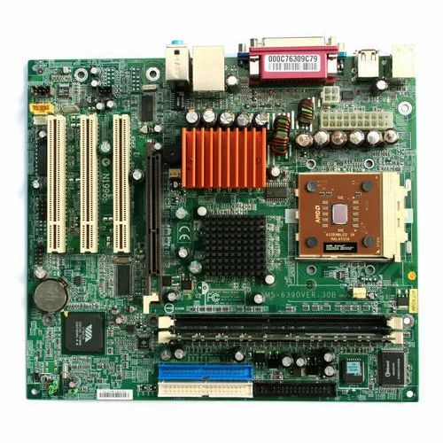

**Fig.1**

**2. RAM Modules:** RAM stands for Random Access Memory. It is also called the main memory. RAM is a temporary data storage device in computers and other devices. SRAM,DRAM, SDRAM, DDR etc are the various types of RAM available. A memory module or RAM stick is a narrow-printed circuit board that holds memory chips (RAM chips).

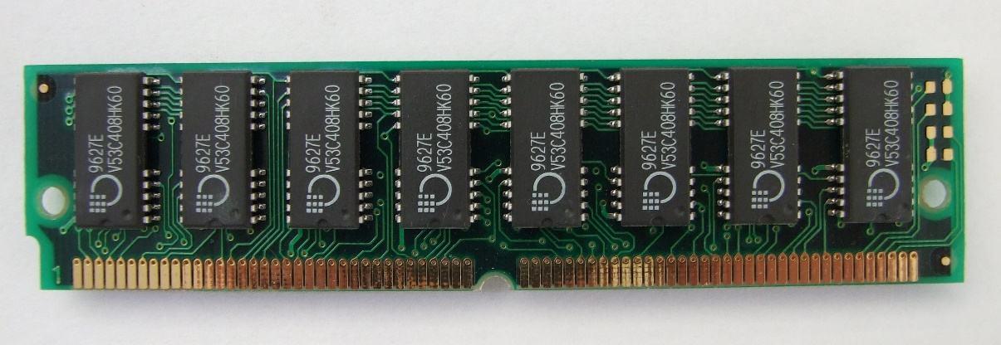

**Fig.2**

SRAM (static RAM) is random access memory (RAM) that retains data bits in its memory as long as power is being supplied. You can lose data if your SRAM is not powered. SRAM does not offer to refresh programs. SRAM has a low storage capacity(about 1MB).

Dynamic random access memory (DRAM) is a type of semiconductor memory that is typically used for the data or program code needed by a computer processor to function. The advantage of a DRAM is it only requires a single transistor compared to around six in a typical static RAM, SRAM memory cell. The costs of DRAM are much lower than those for SRAM,and they are able to provide much higher levels of memory density(about 1GB).

SDRAM (synchronous DRAM) is a generic name for various kinds of DRAM that are synchronized with the clock speed that the microprocessor is optimized for. That is same external clock pulse can be used to operate both SRAM and processor. This tends to increase the number of instructions that the processor can perform in a given time.

DDR Stands for "Double Data Rate." It is an advanced version of SDRAM, DDR-SDRAM can transfer data twice as fast as regular SDRAM chips. This is because DDR memory can send and receive signals twice per clock cycle. DDR operates about 2.5 V and DDR2 averages about 1.8 V, with DDR3 the voltage is reduced to 1.5 V.DDR3 has transfer rates between 800MT/s and 1600MT/s.DDR4 is the latest generation of DDR. It has the lowest operating voltage of 1.2 V and has higher transfer rates than previous generations. DDR5 launch speeds delivery nearly double the bandwidth of DDR4. It also enables scaling memory performance without degrading channel efficiency at higher speeds under real-world conditions. Crucial DDR5 memory will operate at 4800MT/s at launch, which is 1.5x the maximum standard DDR4 speed.

**3. Daughter cards:** A daughterboard (daughter card) is a type of circuit board that plugs in or is attached to the motherboard or similar expansion card to extend its features and services.



**Fig.3**

A daughterboard is connected directly to the motherboard. Like a motherboard, a daughterboard has sockets, pins, plugs and connectors to be attached to other boards.Today, these boards are not found or used in desktop computers. They were replaced with ISA card, PCI card and onboard options.With the rise of connective USB ports and other technology, it has become less necessary to upgrade devices with daughtercards or daughterboards.

**4. Bus Slots:** An expansion slot is a socket on the motherboard that is used to insert an expansion card, which provides additional features to a computer such as video, sound, advanced graphics, Ethernet or memory.



**Fig.4**

PATA stands for Parallel Advanced Technology Attachment and SATA stands for Serial Advanced Technology Attachment both are two bus interfaces used for connecting secondary storage devices like hard disks, optical drives.

Serial refers to the fact that data is sent one bit at a time down a single connection in each direction. There’s a separate connection for data going in to and out of the device.Parallel refers to the fact that data is sent 16 bits at a time through a single 16-bit connection, which is used for data traveling in both directions.

SCSI stands for Small Computer System Interface is a set of standards for physically connecting and transferring data between computers and peripheral devices.

IDE stands for Integrated Drive Electronics is a standard interface for connecting a motherboard to storage devices such as hard drives and CD/DVD drives.

PCI (Peripheral Component Interconnect)is a bus standard that connects the computer motherboard and external devices. PCIe (peripheral component interconnect express) is an interface standard for connecting high-speed components. Every desktop PC motherboard has a number of PCIe slots.

**5. SMPS:** SMPS stands for Switched-Mode Power Supply. It is an electronic power supply that uses a switching regulator to convert electrical power efficiently.



**Fig. 5**

It is a power supply unit (PSU) generally used in computers to convert the voltage into the computer acceptable range. Technically briefing, an SMPS in a desktop system that converts 220V AC and 50HZ into +5V, -5V, +12V and +3.3 V DC at various electrical components in the computer.

**6. Internal Storage:** A storage device is an integral part of the computer hardware which stores information or data to process the result of any computational work. Internal storage is a storage device that's internal (inside the case) and is not a removable storage or external storage. For example, the hard drive inside your computer is an example of internal storage.HDD (Hard Disk Drive) also known as fixed disk uses magnetic tape for the storage of data. HDD has a moving read/write head to access data from storage like a gramophone player and slower to read and write. Unlike HDD, SSD (Solid State Drive) has no moving parts, and it obtains data from storage instantly. SSD can give faster performance than traditional magnetic-based computer storage devices. Although both of them perform the same task.

 

**Fig 6.i Fig 6.ii**

**7. Interfacing ports:**A port is a connection or a jack provided on a computer to connect external or peripheral devices to the computer, for example, you will need a port on your device to connect a keyboard, mouse, pen-drives, etc. So, it acts as an interface or a point of attachment between [computer](https://www.javatpoint.com/computer-fundamentals-tutorial) and external devices. It is also called a communication port, as it is the point where you plug in a peripheral device to allow data transfer or communication between the device and computer. Generally, they are four to six in number and present on the back or sides of the computer.

Based on the type of protocol used for communication, computer ports can be of two types: Serial Ports and Parallel Ports.

1. Serial Ports



**Fig 7.i**

This type of ports provides an interface to connect to peripheral devices using a serial protocol. In this port, the rate of transmission of data is one bit at a time through a single communication line. For example, D-Subminiature or D-sub connector is a commonly used serial port, which carries RS-232 signals.

1. Parallel Ports

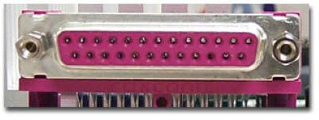

**Fig 7.ii**

As the name suggests, a parallel port is an interface that allows communication or data transfer between a computer and a device in a parallel manner through more than one communication line. For example, a printer port is a parallel port.

Some computer ports are:



Fig:**PS/2** Fig: **VGA**

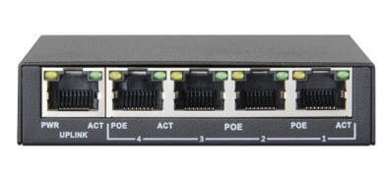

Fig:**DVI** Fig: **RJ-45**



Fig: **HDMI**

**8. Specifications of desktop and server class:**

**Desktop:**

|  |  |
| --- | --- |
| Processor | Core i5 |
| Processor speed | 3.90 GHz |
| Number of cores | 4 |
| Typical Memory | 32GB |
| Cache size | L1:8KB -1MB, L2:256KB - 3MB |
| Memory type | DDR4 |

**Web Server:**

|  |  |
| --- | --- |
| Processor | Intel® Xeon® Bronze 3206R  Processor (Multiple Processors) |
| Processor speed | 1.90 GHz |
| Number of cores | 8 |
| Typical Memory | 512GB |
| Cache size | L1:1-2MB, L2:8MB, L3:32-64MB |
| Memory type | DDR4 |

**Result:**

Familiarisation of computer and hardware done successfully.

**LAB CYCLE:1**

**EXPERIMENT NO:2**

**Date:**

**Aim:** Familiarisation of OS installation.

Oracle Virtual Box is already installed on your Desktop.

1. Create a Virtual Machine with sufficient RAM (nearly half the RAM of your

Desktop).

2. Create a virtual hard disk (vmdk) of 20 GB (variable size).

3. Download Ubuntu 20.04 Desktop iso (64 bit) from

https://ubuntu.com/download/desktop/thank-you?

version=20.04.4&architecture=amd64

(or from http://10.2.7.253/downloads for quicker download)

4. Attach this iso to the Virtual Machine as CD Drive.

5. Boot from it. Execute gparted

6. Create 2 Primary partitions of equal size and install Ubuntu in one of them.

7. Make a copy of the vmdk file for later experiments.

8. You can also install another OS to the other partition.

Write down a description of Virtualbox and vmdk format. Take the screenshots of

Steps 1,2,4 and 6 and affix.

**Solution:**

VirtualBox is an open-source software for virtualizing the x86 computing

architecture. It acts as a hypervisor, creating a VM (virtual machine) where the user

can run another OS (operating system).

VMDK (short for Virtual Machine Disk) is a file format that describes

containers for virtual hard disk drives to be used in VM.

**Installation of Ubuntu using VirtualBox:**

1.We have installed VirtualBox and you have downloaded the Ubuntu. Now set to

install Linux in VirtualBox.

2.Start VirtualBox, and click on the New symbol. Give the virtual OS a relevant name.

3.Allocate RAM to the virtual OS.



4.Create a virtual disk. This serves as the hard disk of the virtual Linux system.

5.Choose VDI file type as file type for new virtual hard disk.

6.Choose either the “Dynamically allocated” or the “Fixed size” option for

creating the virtual hard disk.

7.Allocate size for virtual hard disk (recommended size is 20GB).



8.Install Ubuntu

9.



10. Open the VM box. It shows all the details and properties of the virtual box.



**Installation of another OS (Linux Mint) to the other partition:**

1. Download Linux Mint OS.

2. Choose



3. 

4. Install linux mint.

**Result:**

Program executed successfully and output is verified.

**LAB CYCLE:2**

**EXPERIMENT NO: 3**

**Date:**

**TEXT EDITOR**

**Aim:** Study of a terminal based text editor such as Vim or Emacs.

There are many ways to edit files in Unix. Editing files using the screen-oriented text editor vi is one of the best ways. This editor enables you to edit lines in context with other lines in the file. An improved version of the vi editor which is called the VIM has also been made available now. Here, VIM stands for Vi IMproved. The vi editor was developed by William Joy as a more visual version of his own command line editor program called ex, which was becoming popular as a text editor.

The vi editor uses the terminal window for editing a file. For an example, run the following command to open a new file or an existing file of the same name:

vi filename

There are two ways of working in vi:

* Insert Mode: This mode enables you to insert text into the file. Everything that's typed in this mode is interpreted as input and placed in the file. To come out of the insert mode, press the Esc key, which will take you back to the command mode.
* Command Mode: This mode enables you to perform administrative tasks such as saving the files, executing the commands, moving the cursor, cutting (yanking) and pasting the lines or words, as well as finding and replacing. In this mode, whatever you type is interpreted as a command.

Commands and descriptions:

* vi filename

#Creates a new file if it already does not exist, otherwise opens an existing file.

* vi -R filename

#Opens an existing file in the read-only mode.

* view filename

#Opens an existing file in the read-only mode.

Create a new file testfile if it already does not exist in the current working directory −

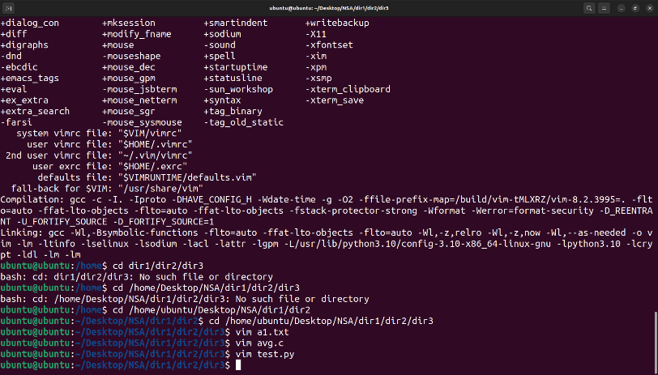

The above command will generate the following output −



The tilde (~) on each line following the cursor. A tilde represents an unused line. If a line does not begin with a tilde and appears to be blank, there is a space, tab, newline, or some other non-viewable character present.

**a) Cursor operations**

In command mode we can position the cursor anywhere in the file. Since you begin all basic edits (changing, deleting, and copying text) by placing the cursor at the text that you want to change, you want to be able to move the cursor to that place as quickly as possible.

There are vi commands to move the cursor:

* Up, down, left, or right—one character at a time.
* Forward or backward by blocks of text such as words, sentences, or paragraphs.
* Forward or backward through a file, one screen at a time.

An underscore marks the present cursor position. Circles show movement of the cursor from its current position to the position that would result from various vi commands.

Single Movements

The keys h, j, k, and l, right under your fingertips, will move the cursor:

h: Left, one space

j: Down, one line

k: Up, one line

l: Right, one space

You can also use the cursor arrow keys (←, ↓, ↑, →), + and - to go up and down, or the ENTER and BACKSPACE keys.

**b) Manipulate text**

1. Open a new or existing file with vim filename.
2. Type i to switch into insert mode so that you can start editing the file.

Enter or modify the text with your file.

1. Once you're done, press the escape key Esc to get out of insert mode and back to command mode.
2. Type :wq to save and exit your file.

Vim commands for editing#:

Those who use Vim tend to use the term "yank" where most people would use the terms copy and paste. Therefore, the command for copying a word is yw, which stands for yank word, and the command for pasting whatever has been copied is p, meaning put. If you look up additional commands in the future, it can be confusing if you don't know what yank and put mean when using Vim.

You also have two options for how to select text. You can either use commands like dd, which deletes a single line, and yy, which copies a single line, or you can highlight text and then copy it to the unnamed register. The paste commands work the same whether you've highlighted text or used a command to automatically copy it.

As with movement commands, putting a number in front of the command can increase the number of times a task is completed. For instance, putting a number in front of yy will increase the number of lines copied, so 5yy will copy five lines.

yy - Copies a line

yw - Copies a word

y$ - Copies from where your cursor is to the end of a line

v - Highlight one character at a time using arrow buttons or the h, k, j, l buttons

V - Highlights one line, and movement keys can allow you to highlight additional lines

p - Paste whatever has been copied to the unnamed register

d - Deletes highlighted text

dd - Deletes a line of text

dw - Deletes a word

D - Deletes everything from where your cursor is to the end of the line

. - Repeats the last action

one

Vim commands for working with multiple files#:

You can also edit more than one text file at a time. Vim gives you the ability to either split your screen to show more than one file at a time or you can switch back and forth between documents. As with other functions, commands make going between documents or buffers, as they're referred to with Vim, as simple as a few keystrokes.

:bn - Switch to next buffer

:bp - Switch to previous buffer

:bd - Close a buffer

:sp [filename] - Opens a new file and splits your screen horizontally to show more than one buffer

:vsp [filename] - Opens a new file and splits your screen vertically to show more than one buffer

:ls - Lists all open buffers

Ctrl + ws - Split windows horizontally

Ctrl + wv - Split windows vertically

Ctrl + ww - Switch between windows

Ctrl + wq - Quit a window

Ctrl + wh - Moves your cursor to the window to the left

Ctrl + wl - Moves your cursor to the window to the right

Ctrl + wj - Moves your cursor to the window below the one you're in

Ctrl + wk - Moves your cursor to the window above the one you're in

**c) Search for patterns:**

Vim commands for searching text#:

Like many other text editors, Vim allows you to search your text and find and replace text within your document. If you opt to replace multiple instances of the same keyword or phrase, you can set Vim up to require or not require you to confirm each replacement depending on how you put in the command.

/[keyword] - Searches for text in the document where keyword is whatever keyword, phrase or string of characters you're looking for

?[keyword] - Searches previous text for your keyword, phrase or character string

n - Searches your text again in whatever direction your last search was

N - Searches your text again in the opposite direction

:%s/[pattern]/[replacement]/g - This replaces all occurrences of a pattern without confirming each one

:%s/[pattern]/[replacement]/gc - Replaces all occurrences of a pattern and confirms each

We can use the slash to search for a word, and then use the dot to replace it.

open the sample.txt file using the Vim editor:

$ vim sample.txt

we need to press the forward-slash(/) key, then search for the word “article”:

/article

This will highlight the first occurrence of the word “article” and we can press the Enter key to jump to it.

**d) Global search and replace**

We can use the slash to search for a word, and then use the dot to replace it.

open the file using the Vim editor:

$ vim filename

we need to press the forward-slash(/) key, then search for the word:

/word to be searched

This will highlight the first occurrence of the word and we can press the Enter key to jump to it.

We can then type in the cgn command combo:

cgn

This Vim editor command finds the last thing we searched for, deletes it, and then put us into insert mode.

We can then press the Esc key to return to normal mode.

Next, we need to press the “N” key to jump to the next occurrence of the word and press the Dot (.) key to auto-replace it with the word.

This is the simplest method to perform a basic search and replace in Vim editor.

Search and Replace Using the substitute Command

Basic syntax:

:s/<search_phrase>/<replace_phrase>/options

* All Occurrences

:%s/article/tutorial/g

* Case-Insensitive

:%s/vim/baeldung/gi

* With Confirmation

:%s/article/tutorial/gc

* Within Specific Lines

:start_line_number, end_line_number s/<search_term>/<replace_term>/g

* Whole Word

:s/\<cover\>/go through/gi

**Result:**

Study of text editor has been done successfully.

**LAB CYCLE:2**

**EXPERIMENT NO:4**

**Date:**

**BASIC LINUX COMMANDS**

**Aim:** Basic Linux commands, familiarity with following commands/operations expected.

**1. man:** is used to display the user manual of any command that we can run on the terminal. It provides a detailed view of the command which includes NAME, SYNOPSIS, DESCRIPTION, OPTIONS, EXIT STATUS, RETURN VALUES, ERRORS, FILES, VERSIONS, EXAMPLES, AUTHORS and SEE ALSO.

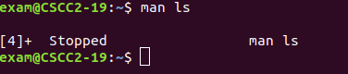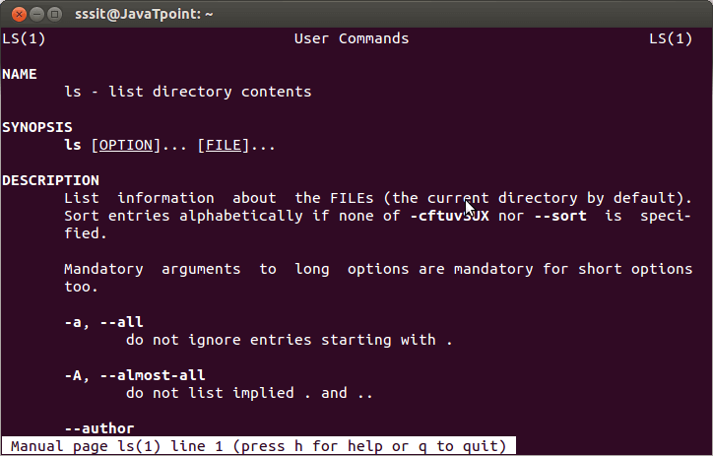

**2. ls, echo, read**

**ls:** is a Linux shell command that lists directory contents of files and directories. Some practical examples of ls command are shown below.

Options:

-t: It sorts the file by modification time, showing the last edited file first.

-l: To show long listing information about the file/directory.

-lh: To display file size in easy-to-read format.

-a: To show all the hidden files in the directory.

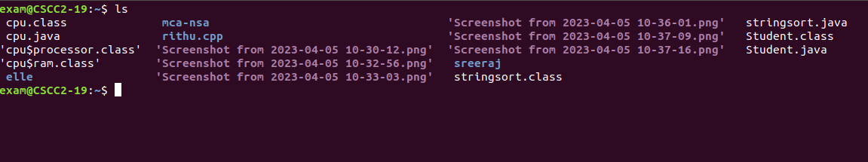

**echo:** used for displaying lines of text or string which are passed as arguments on the command line.



**read:** is used to read from a file descriptor.

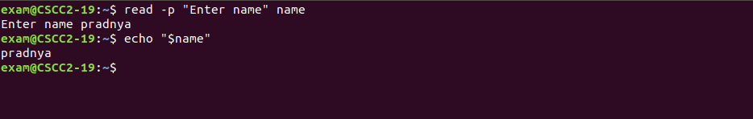

**3. more, less, cat**

**more**: reads files and displays the text one screen at a time.

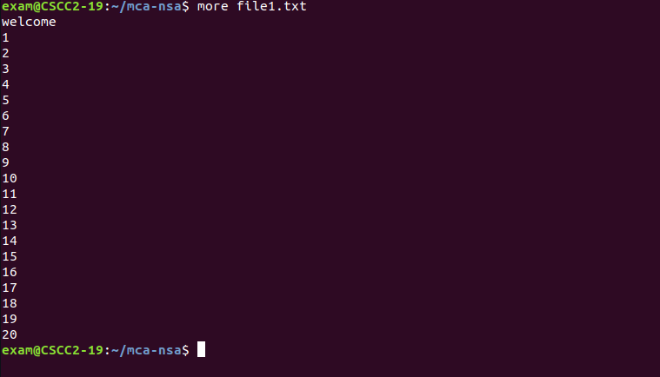

**less:** used for filtering and viewing text files one screen page at a time.

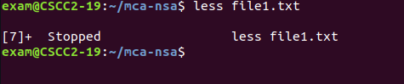

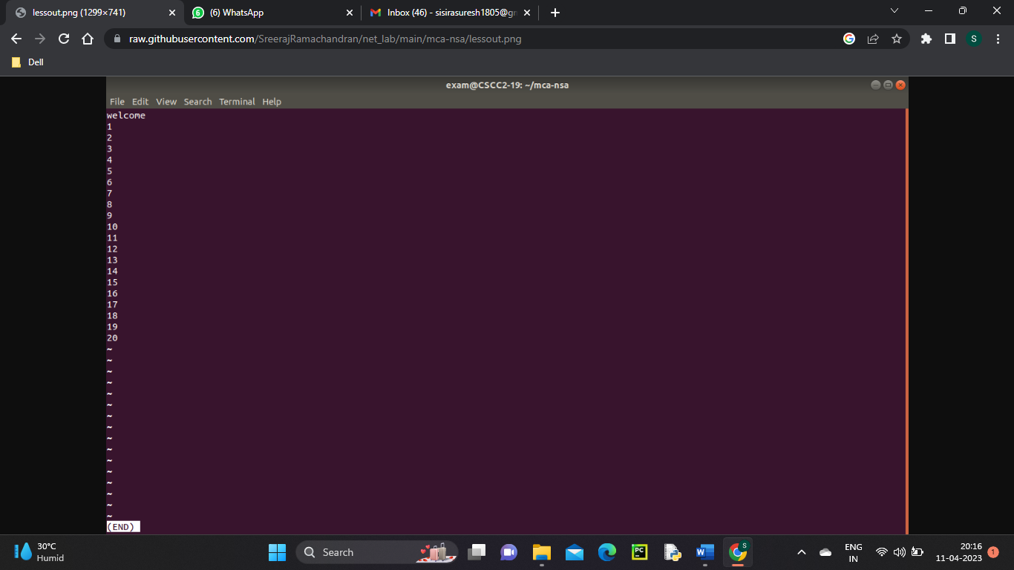

**cat:** used to display the content of a file, copy content from one file to another, concatenate the contents of multiple files, display the line number, display $ at the end of the line, etc.

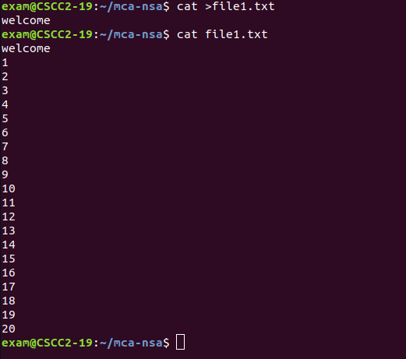

**4. cd, mkdir, pwd, find**

**cd:** cd command in linux known as change directory command. It is used to change current working directory.

Syntax: cd [directory_name]



**mkdir:** mkdir command in Linux allows the user to create directories (also referred to as folders in some operating systems). This command can create multiple directories at once as well as set the permissions for the directories.

Syntax: mkdir [options...] [directories ...]

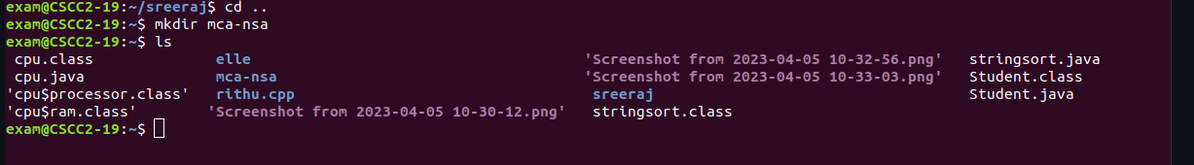

**pwd:** pwd stands for Print Working Directory. It prints the path of the working directory, starting from the root.

Syntax: pwd -L: Prints the symbolic path.

pwd -P: Prints the actual path.



**find:** The find command in UNIX is a command line utility for walking a file hierarchy. It can be used to find files and directories and perform subsequent operations on them. It supports searching by file, folder, name, creation date, modification date, owner and permissions.

Syntax: find [where to start searching from]

[expression determines what to find] [-options] [what to find]



**5. mv, cp, rm, tar**

**mv:** mv stands for move. mv is used to move one or more files or directories from one place to another in a file system like UNIX. It has two distinct functions:

(i) It renames a file or folder.

(ii) It moves a group of files to a different directory.

Syntax: mv [Option] source destination



**cp:** cp stands for copy. This command is used to copy files or group of files or directory. It creates an exact image of a file on a disk with different file name. cp command require at least two filenames in its arguments.

Syntax: cp [OPTION] Source Destination



**rm:** rm stands for remove here. rm command is used to remove objects such as files, directories, symbolic links and so on from the file system like UNIX. To be more precise, rm removes references to objects from the filesystem, where those objects might have had multiple references.

Syntax: rm [OPTION]... FILE...



**tar:** The Linux ‘tar’ stands for tape archive, is used to create Archive and extract the Archive files. tar command in Linux is one of the important commands which provides archiving functionality in Linux. We can use Linux tar command to create compressed or uncompressed Archive files and also maintain and modify them.

Syntax: tar [options] [archive-file] [file or directory to be archived]



**6.wc, cut, paste**

**wc:** wc stands for word count.It is used to find out number of lines, word count, byte and characters count in the files specified in the file arguments.

Syntax: wc [OPTION]... [FILE]...



**cut:** The cut command in UNIX is a command for cutting out the sections from each line of files and writing the result to standard output. It can be used to cut parts of a line by byte position, character and field.

Syntax: cut OPTION... [FILE]...

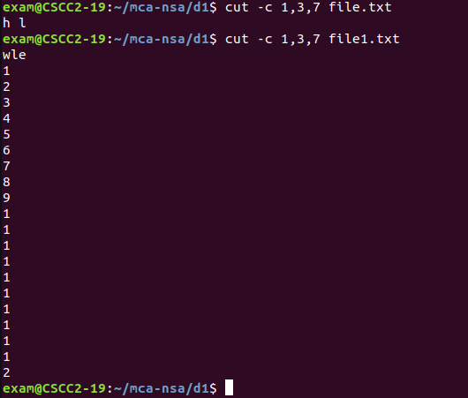

**paste:** paste command is one of the useful commands in Unix or Linux operating system. It is used to join files horizontally (parallel merging) by outputting lines consisting of lines from each file specified, separated by tab as delimiter, to the standard output.

Syntax: paste [OPTION]... [FILES]...



**7. head, tail, grep, expr:**

**head:** it prints the first 10 lines of the specified files. If more than one file name is provided then data from each file is preceded by its file name.

Syntax: head [OPTION]... [FILE]...

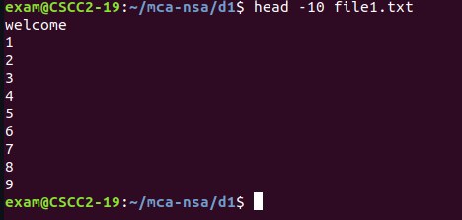

**tail:** it prints the last 10 lines of the specified files. If more than one file name is provided then data from each file is precedes by its file name.

Syntax: tail [OPTION]... [FILE]...

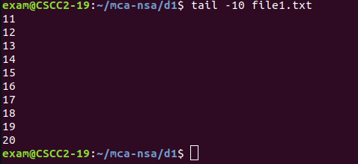

**grep:** the grep filter searches a file for a particular pattern of characters, and displays all lines that contain that pattern. The pattern that is searched in the file is referred to as the regular expression (grep stands for global search for regular expression and print out).

Syntax: grep [options] pattern [files]

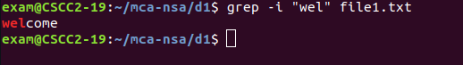

**8. chmod, chown:**

**chmod:** the chmod command is used to change the access mode of a file.The name is an abbreviation of change mode.

Syntax: chmod [reference][operator][mode] file...

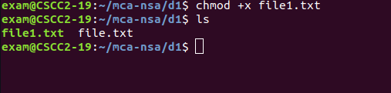

**chown:** it is used to set read, write, execute permission for user. To protect and secure files and directory in Linux we use permissions to control what a user can do with a file or directory.

Syntax: chown [OPTION]… [OWNER][:[GROUP]] FILE…

chown [OPTION]… –reference=RFILE FILE…



**9. Redirections & Piping:**

**Redirection:** whenever an individual runs a command, it can take input, give output, or do both. Redirection helps us redirect these input and output functionalities to the files or folders we want, and we can use special commands or characters to do so.

Append redirection

“>>” standard output

“<<” standard input

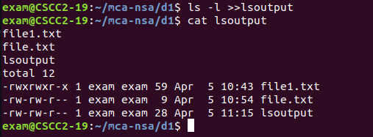

Overwrite Redirection

“>” standard output

“<” standard input

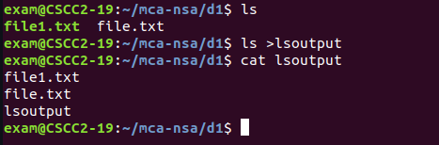

**Piping:** Pipe is used to combine two or more commands, and in this, the output of one command acts as input to another command, and this command’s output may act as input to the next command and so on. It can also be visualized as a temporary connection between two or more commands/ programs/ processes. The command line programs that do the further processing are referred to as filters.

Syntax: command_1 | command_2 | command_3 | .... | command_N

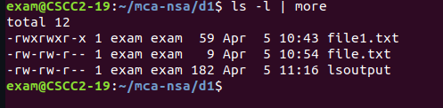

**10. useradd, usermod, userdel, passwd:**

**useradd:** is a command in Linux that is used to add user accounts to your system. It is just a symbolic link to adduser command in Linux and the difference between both of them is that useradd is a native binary compiled with system whereas adduser is a Perl script which uses useradd binary in the background.

Syntax: useradd [options] name_of_the_user



**usermod:** is a command in Linux that is used to change the properties of a user in Linux through the command line. After creating a user we have to sometimes change their attributes like password or login directory etc. so in order to do that we use the Usermod command.

Syntax: sudo usermod -c "This is test user" test_user



**userdel:** is used to delete a user account and related files. This command basically modifies the system account files, deleting all the entries which refer to the username LOGIN. It is a low-level utility for removing the users.

Syntax: userdel [options] LOGIN



**passwd:** passwd command in Linux is used to change the user account passwords. The root user reserves the privilege to change the password for any user on the system, while a normal user can only change the account password for his or her own account.

Syntax: passwd [options] [username]

**11. df,top, ps:**

**df:** is used to displays the amount of disk space available on the file system containing each file name argument.

Syntax: df [OPTION]...[FILE]...



**top:** top command is used to show the Linux processes. It provides a dynamic real-time view of the running system. Usually, this command shows the summary information of the system and the list of processes or threads which are currently managed by the Linux Kernel.



**ps:** it allows multiple processes to operate simultaneously without interfering with each other. Process is one of the important fundamental concept of the Linux OS.

Syntax: ps [options]



**12. ssh, scp, ssh-keygen, ssh-copy-id:**

**ssh:** stands for “Secure Shell”. It is a protocol used to securely connect to a remote server/system. ssh is secure in the sense that it transfers the data in encrypted form between the host and the client. It transfers inputs from the client to the host and relays back the output. ssh runs at TCP/IP port 22.

Syntax: ssh user_name@host(IP/Domain_name)

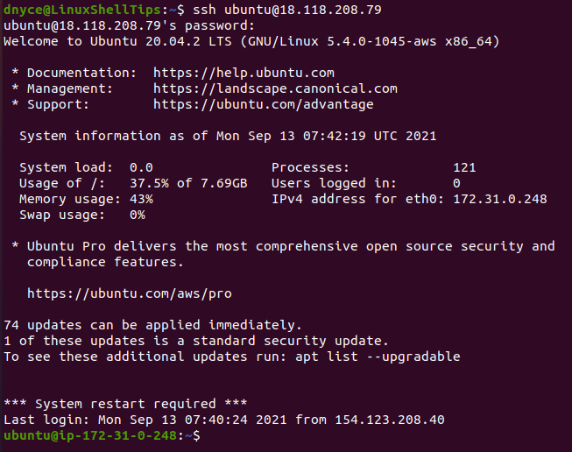

**scp:** scp (secure copy) command in Linux system is used to copy file(s) between servers in a secure way. The SCP command or secure copy allows secure transferring of files in between the local host and the remote host or between two remote hosts. It uses the same authentication and security as it is used in the Secure Shell (SSH) protocol. SCP is known for its simplicity, security and pre-installed availability.

Syntax: scp [-346BCpqrTv] [-c cipher] [-F ssh_config] [-i identity_file] [-l limit] [-o ssh_option] [-P port] [-S program] [[user@]host1:]file1 … [[user@]host2:]file2

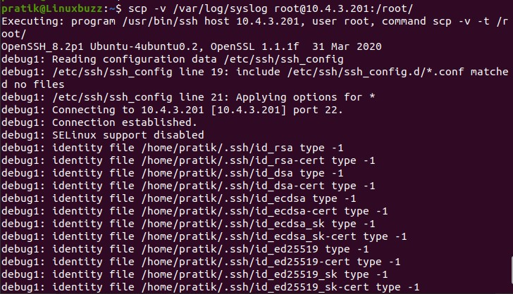

**ssh-keygen:** Secure Shell(SSH) is a cryptographic network protocol used for operating remote services securely. It is used for remote operation of devices on secure channels using a client-server architecture that generally operates on Port 22. SSH is the successor of Telnet. SSH uses public and private keys to validate and authenticate users. ssh-keygen is used to generate these key pairs.

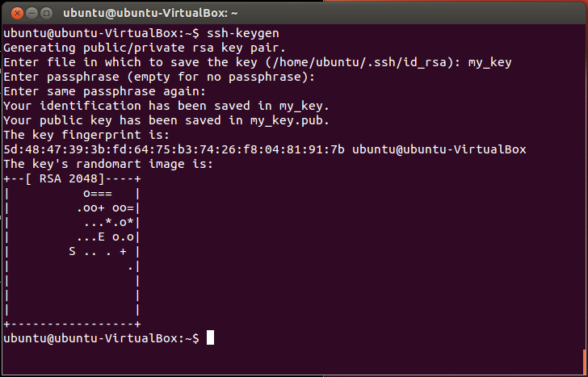

**ssh-copy-id:** is a command that copies the public key of the local host to the authorized keys file of the remote host, allowing password-less and automatic login via SSH.

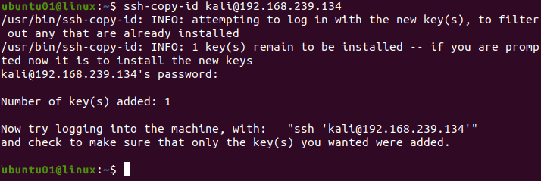

**Basic Linux commands activity questions**

1. Command to display the following message as (Use “New line).

“God!Bless us.

We are starting Shell Scripting”

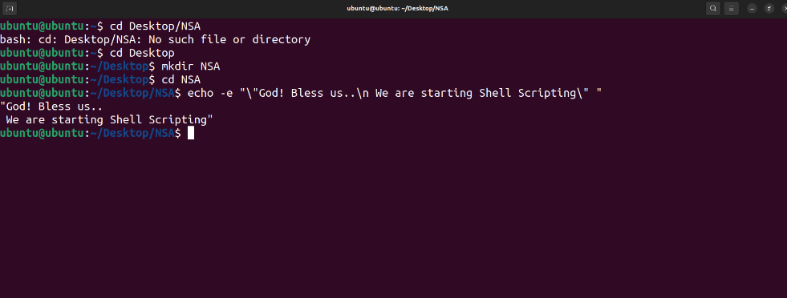

1. Get the manual page of ‘ls’ command. Search for the word “alpha”. Find the next occurrence and then find the previous occurrence.

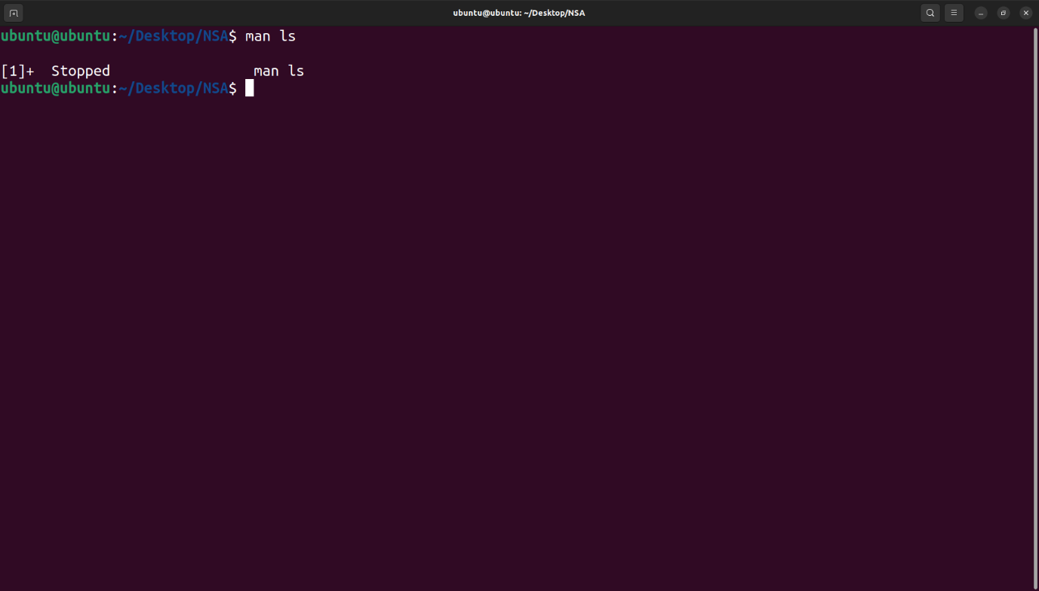

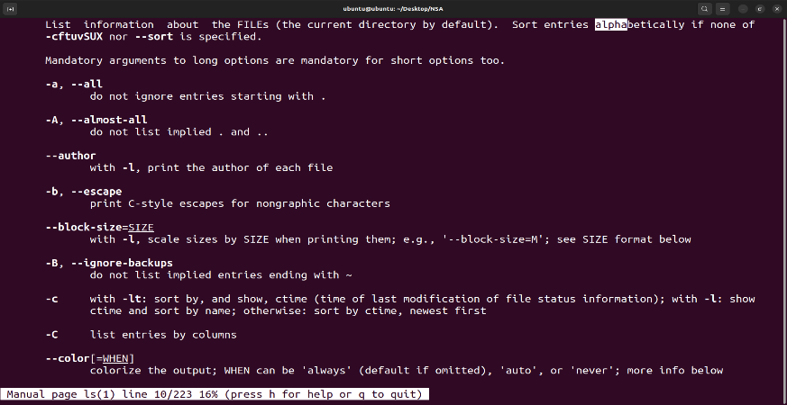

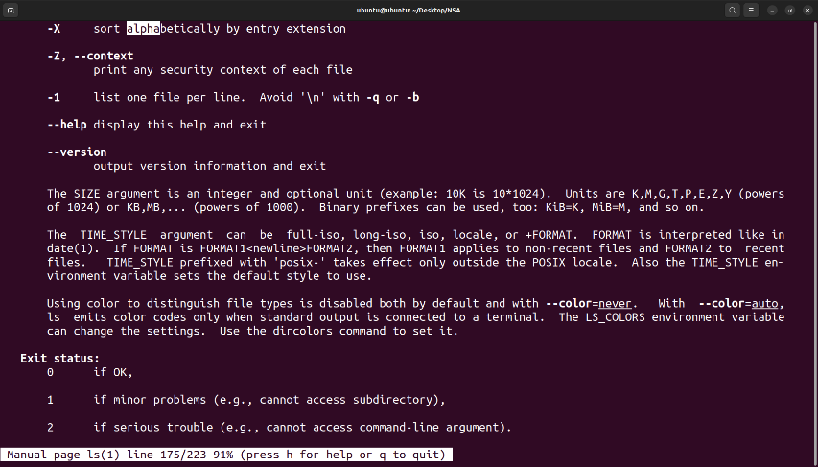

1. Read your name from the keyboard and display it.

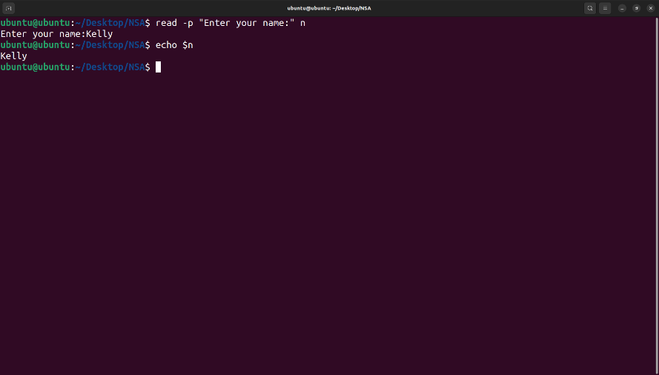

1. Create the directory structure dir1/dir4 and dir1/dir2/dir3 with a single command and then change directory to dir3.

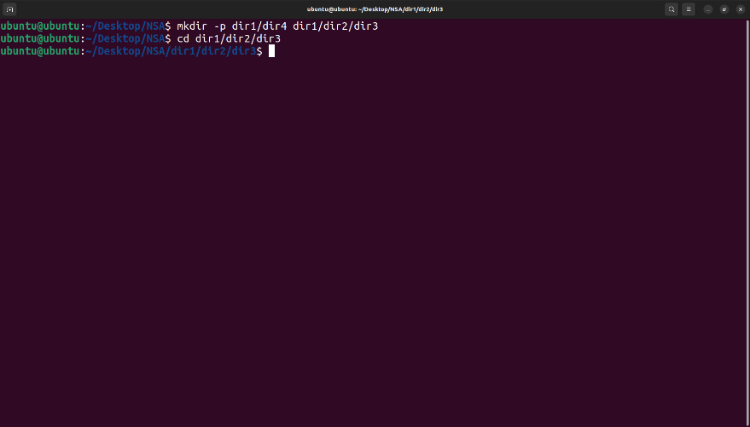

1. Create some files using **V**im.

* Creating a file using vim:
* Start vim by typing vim filename
* To insert text press i
* Now start editing text. Add new text or delete unwanted text.
* One can press Esc and type :wq to save changes to a file and exit from vim]



1. Display the current directory.

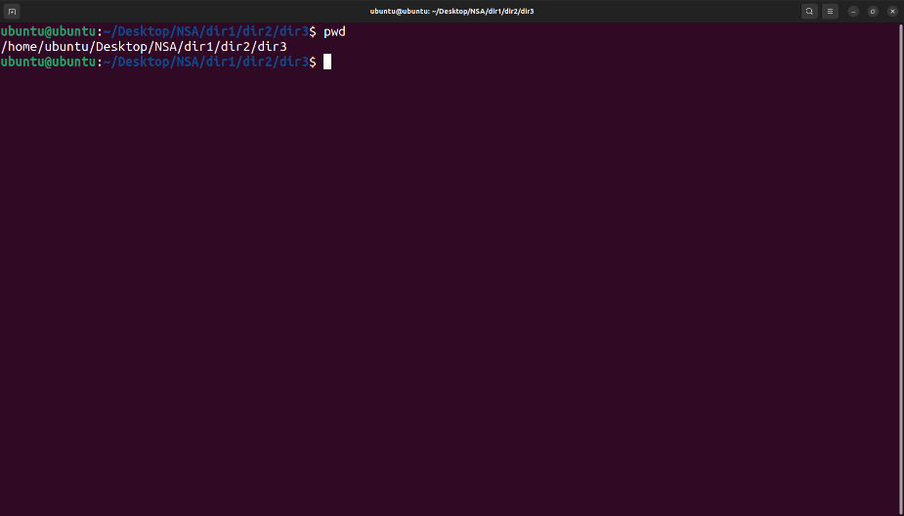

1. Listing files and folders.
2. Listing the contents of dir1 (Qn.4) and all its descendants.

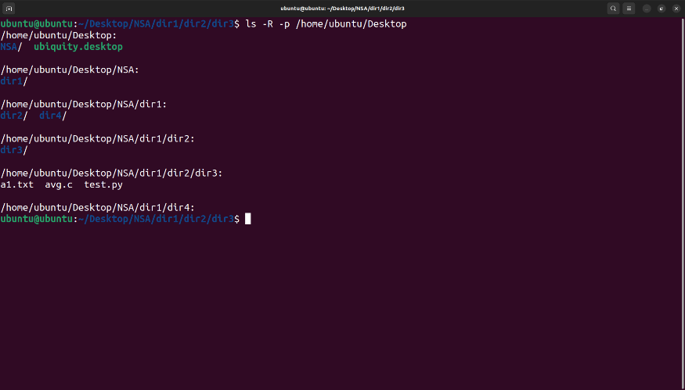

1. Listing the contents of dir3 (Qn.4) in
   1. Alphabetical order
   2. Sorted on Time of modification, newest first
   3. Sorted on Size
   4. Reverse of all above
   5. Long listing of files Sorted on Size with smallest first and size
   6. Displayed in human readable form

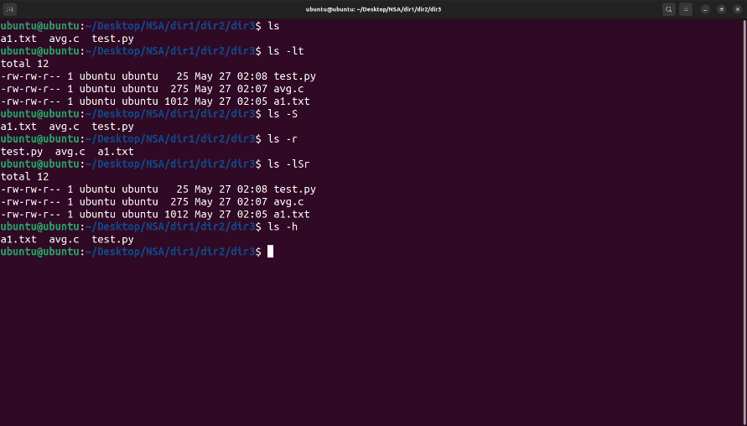

1. Execute **ls** and store the output to a file lsoutput .

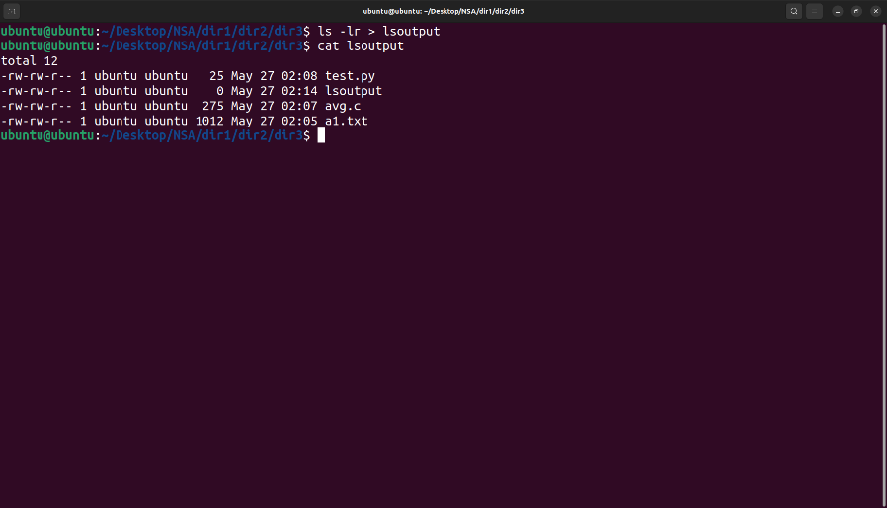

1. Display the file
2. starting with the first 10 lines and

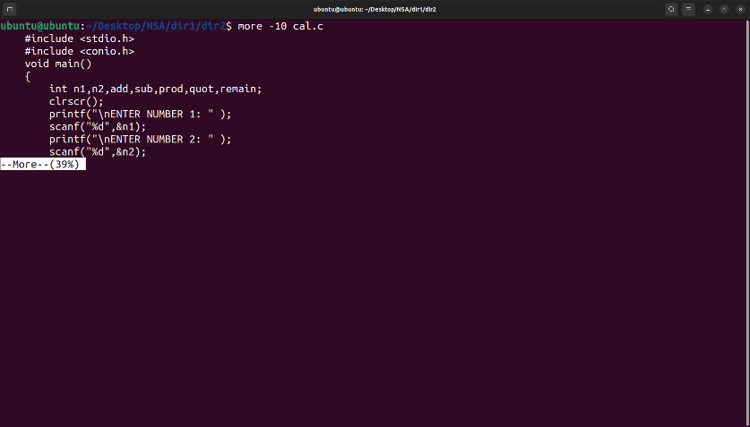

1. starting with the 10th line with provision for
2. Scrolling Up

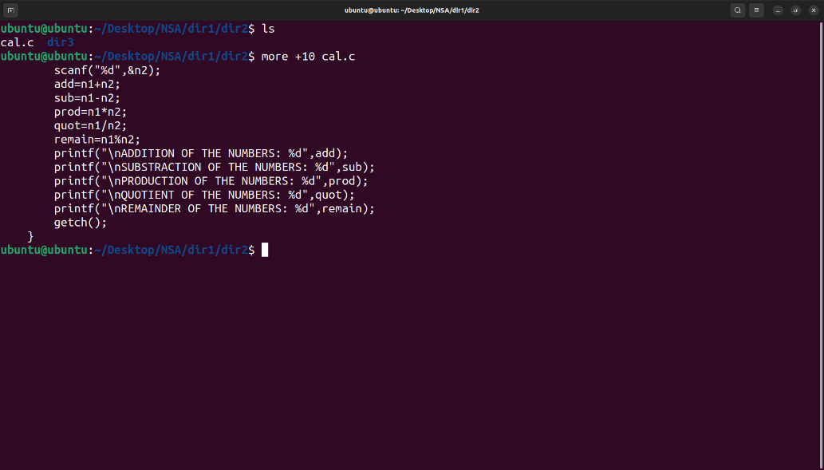

1. Scrolling Up and Down

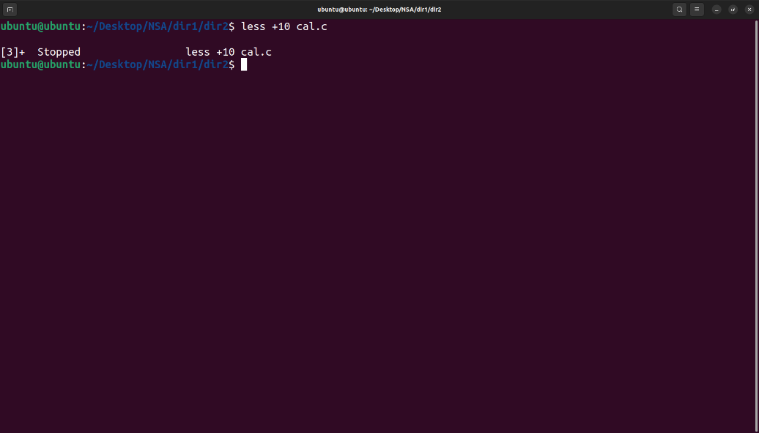

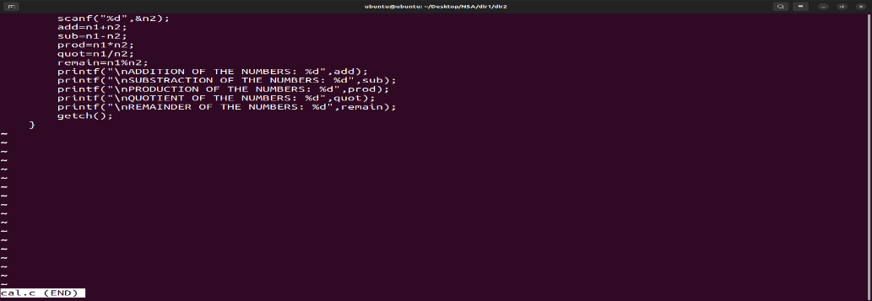

1. Execute **ls -l** and add the output to lsoutput, at the end.

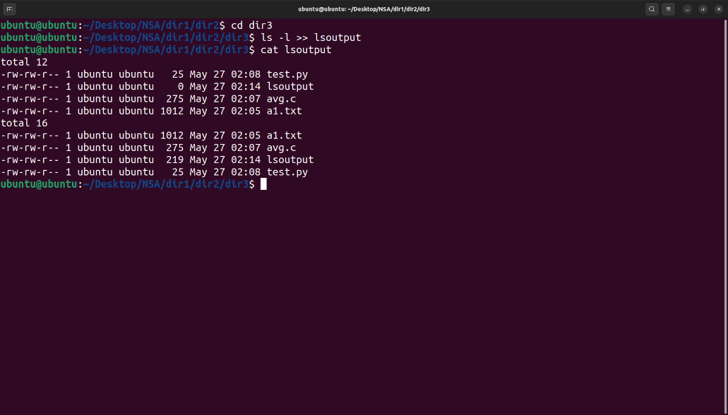

1. Execute **ls -l** and feed the result to less command, to scroll through the directory listing.

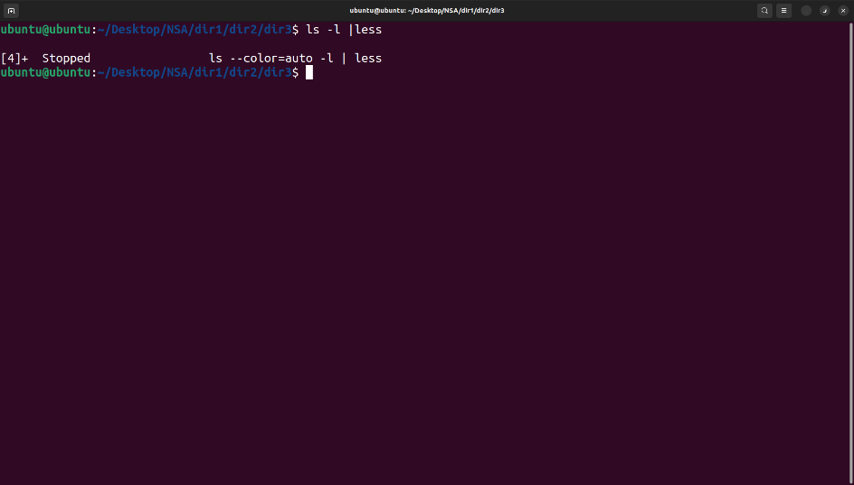

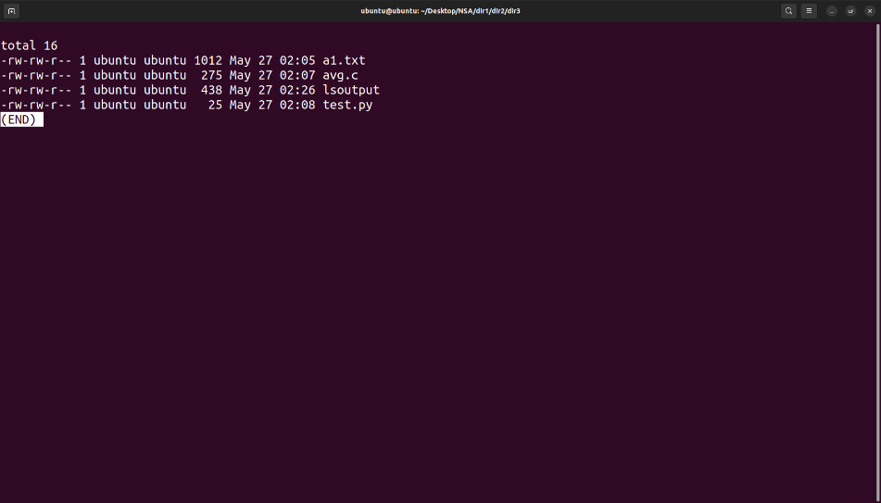

12. Copy the file file1 to newfile.

1. If newfile already exists, it should be replaced.
2. If newfile already exists, it should not be replaced.

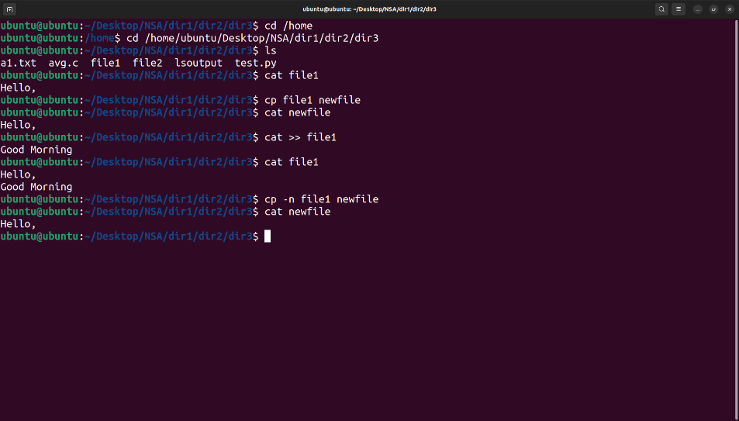

1. If newfile already exists, it should be replaced, but only with the consent of the user.
2. If newfile already exists, it should be replaced only if its contents is older than that of file1.

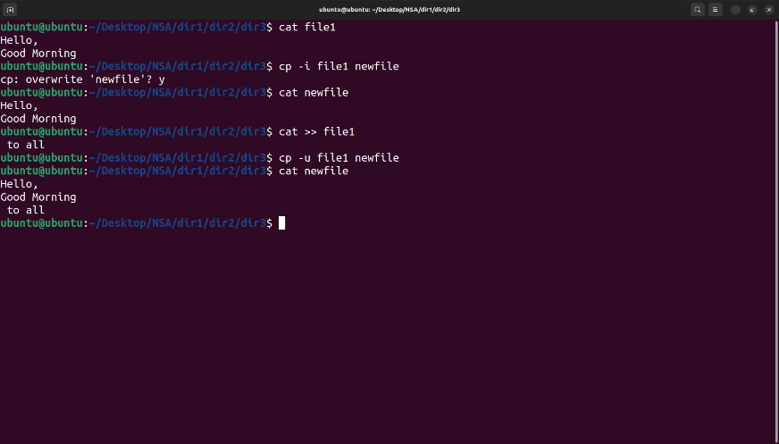

1. Even if newfile is read only.
2. Create a link instead of copying.

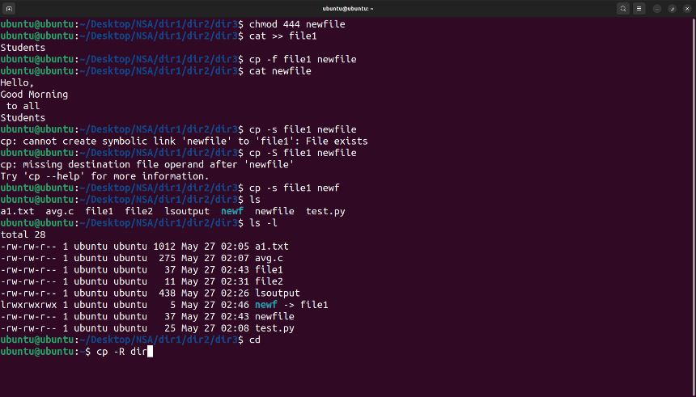

1. Copy the entire directory tree from dir1 of Qn.4 to a new directory dir5

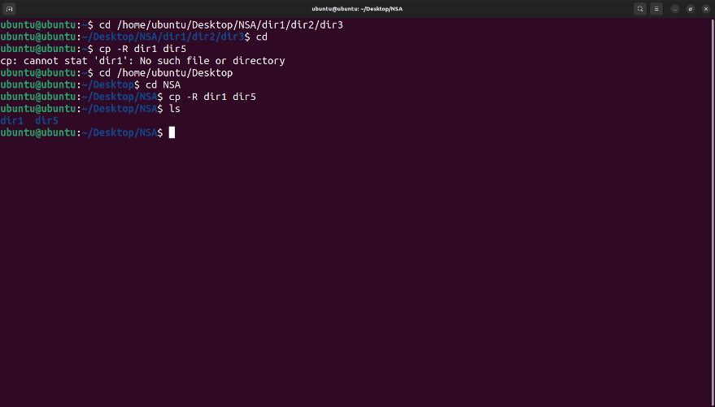

13. Create a new directory, dir6 inside dir1

1. Move all files in dir5 into it.
2. Delete all files where the name starts with a vowel character, upper or lower case.

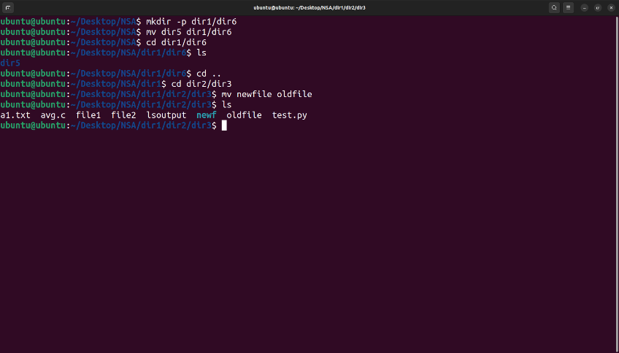

1. Delete all files where the name is at least 3 characters long.
2. Delete all hidden folders, and files.

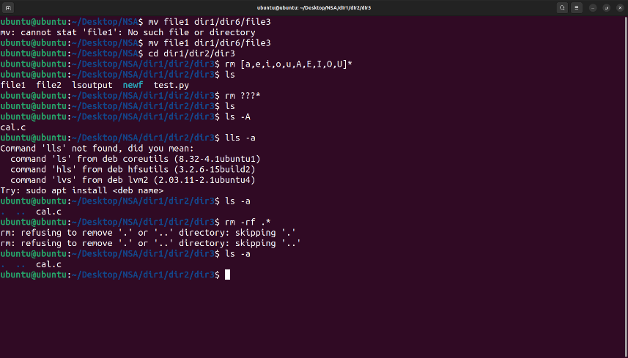

14. Create a file testfile1 using Vim

vim testfile1

1. Set line number

vim testfile1

Press esc

Type :set number



1. Type your name and address with district and pincode

**

1. Copy paste the contents 10 times.

1. Place the cursor in the desired location(at beginning) .

2. Press Esc key then press ‘v’ [To change to visual mode] .

3. Press the ‘y’ key followed by movement command ,‘$’ .

4. Move the cursor to the location where you want to paste the contents.

5. Press ‘10p’ to paste the contents.

1. Replace all occurrence of your district with a neighbouring district.

1. Press Esc key [To change to normal mode].

2. Type “:%s/Erode/Dindigul/gi”





15. Create 2 files testfile2 and testfile3 using **Vim**.

* 1. Modify the permissions of testfile2 using symbolic mode.
     1. Add read permission to others
     2. Revoke write from owner
     3. Set only execute to Group.
     4. Add write to owner, revoke read from others and set read only to group.
     5. Set read and write to all.

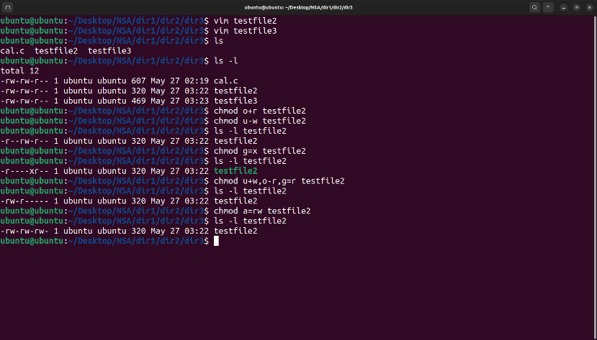

* 1. Modify the permissions of testfile3 using numeric mode
     1. Set read and write to all.
     2. set read,write and execute to owner, read and execute to group and read only to others.

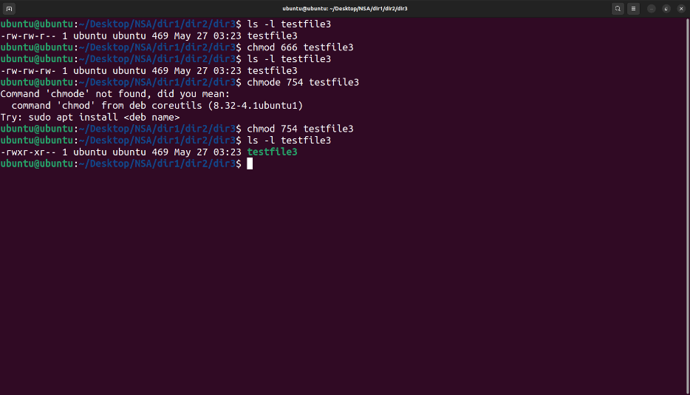

* 1. Set the permissions of testfile2 the same as that of testfile3

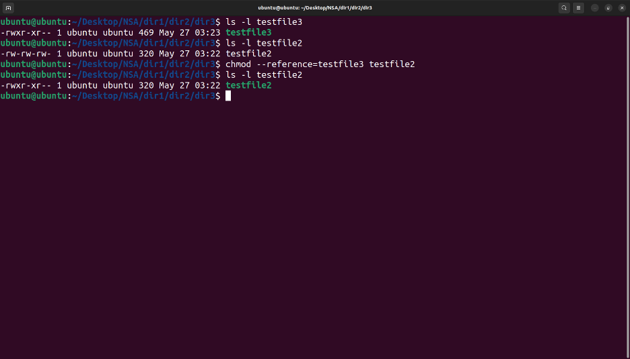

1. Use **head** and **tail** piped with cat /etc/passwd to display the details of
   1. The first 12 users in the system.
   2. The last 7 users in the system.

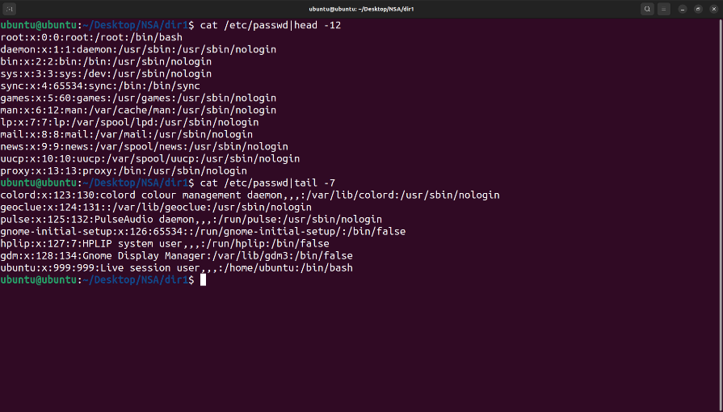

* 1. All but the first 3.

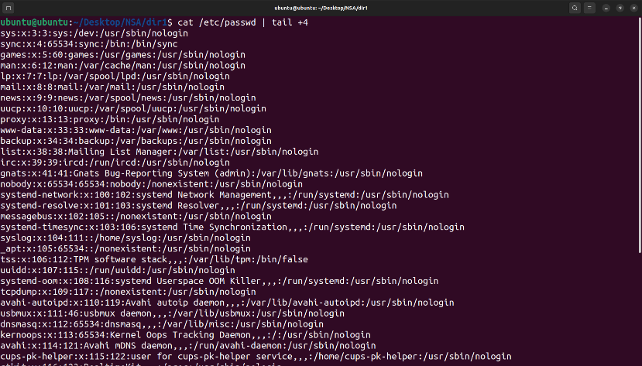

* 1. All but the last 5.

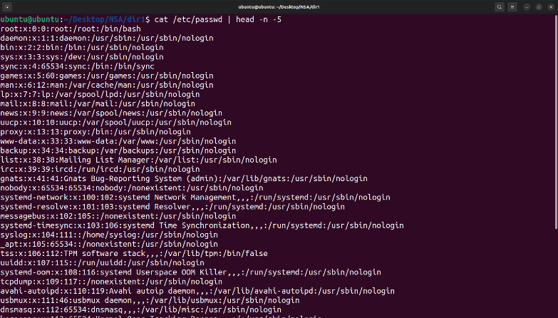

* 1. Only the 9 th.

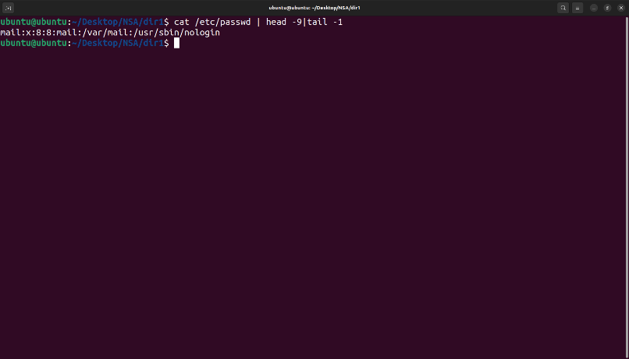

1. Use **grep** to
   1. Display all lines in a file that contains the string “abc”
   2. Display all lines in a file that *does not* contain the string “abc”

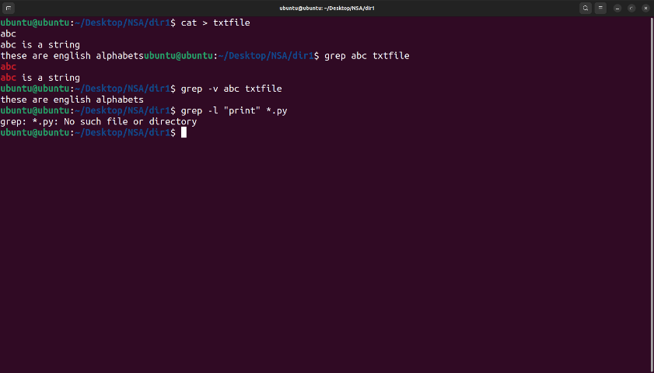

1. Using **expr**
   1. Read two integers X and Y. Display the sum, difference, product, quotient and remainder of these variables.
   2. Read a string, S, a position, p and a length l. Display the substring of length l starting at position p from the string S.



1. a. Add a normal user, user1. Create (if it does not exist) the folder /user1 and set /user1 as the home directory of user1. Also set /bin/bash as the login shell *(Use a single command)*.

b. Modify the user account of user1, to expire it after a specific date.

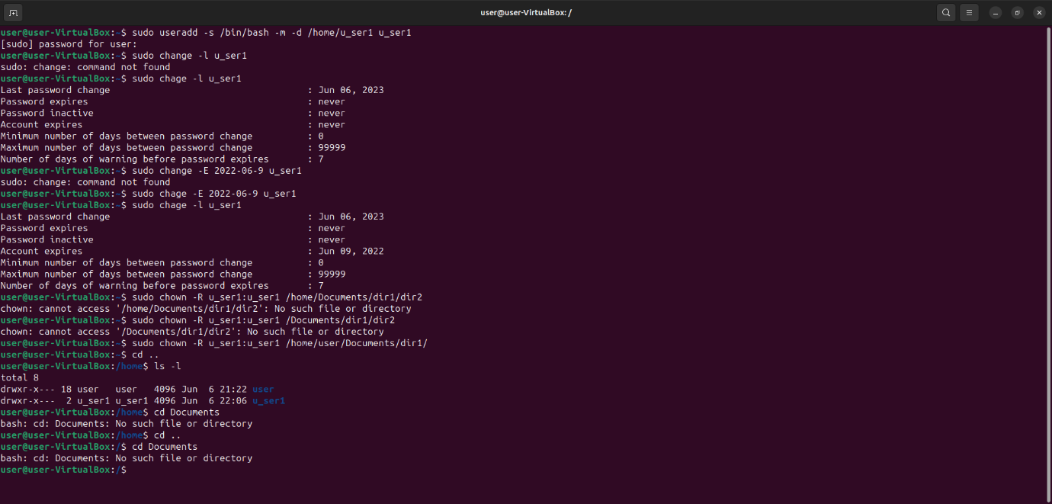

c. Change the owner and group of the directory tree from dir2 and all its contents to user1.

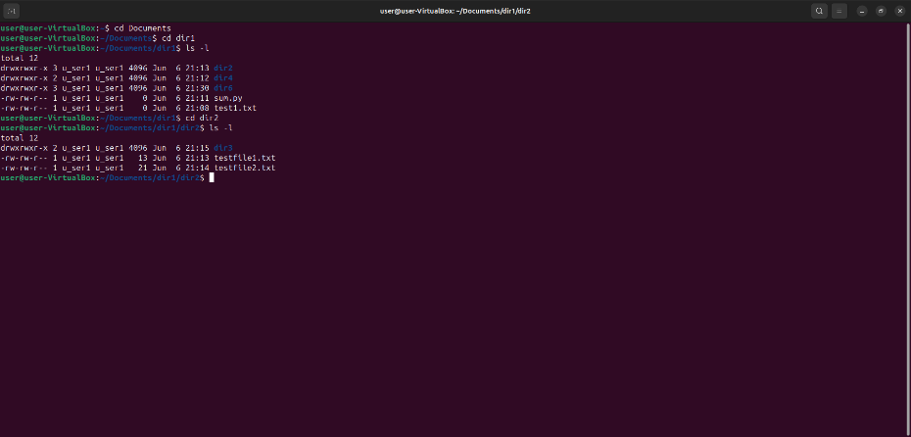

d. Delete the user account user1

* + 1. By retaining the home folder
    2. By deleting the home folder

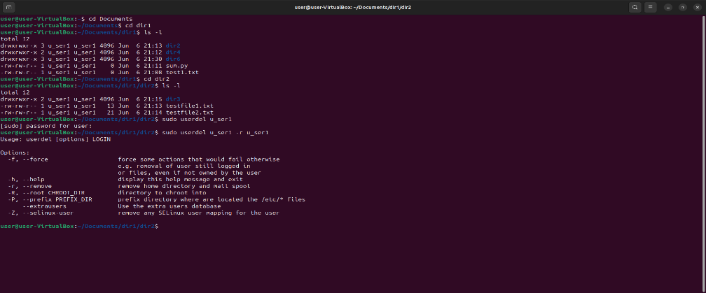

1. Miscellaneous
   1. Using **tar** create a tar.gz file of the folder dir1 of Qn.4 with the name mydir.tar.gz.

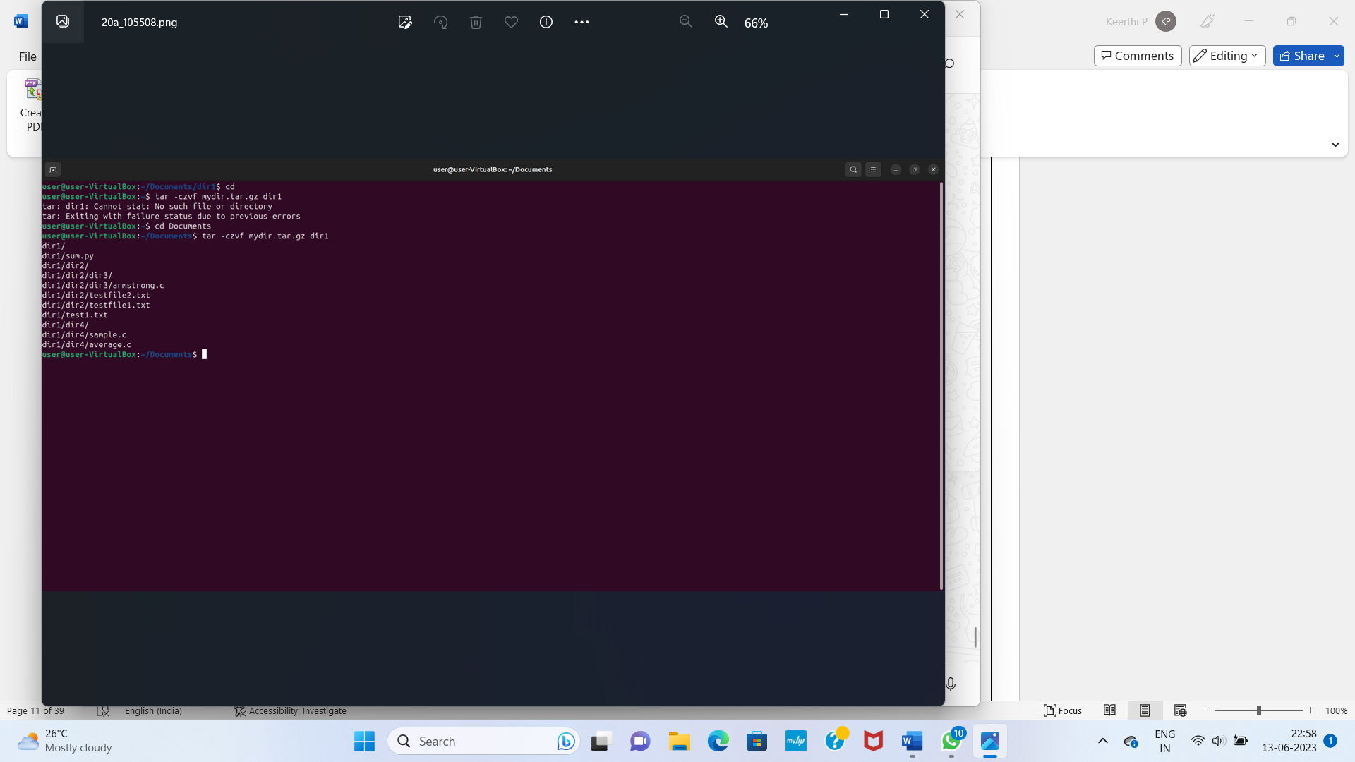

* 1. Extract the contents of mydir.tar.gz to dir6 of Qn.14.

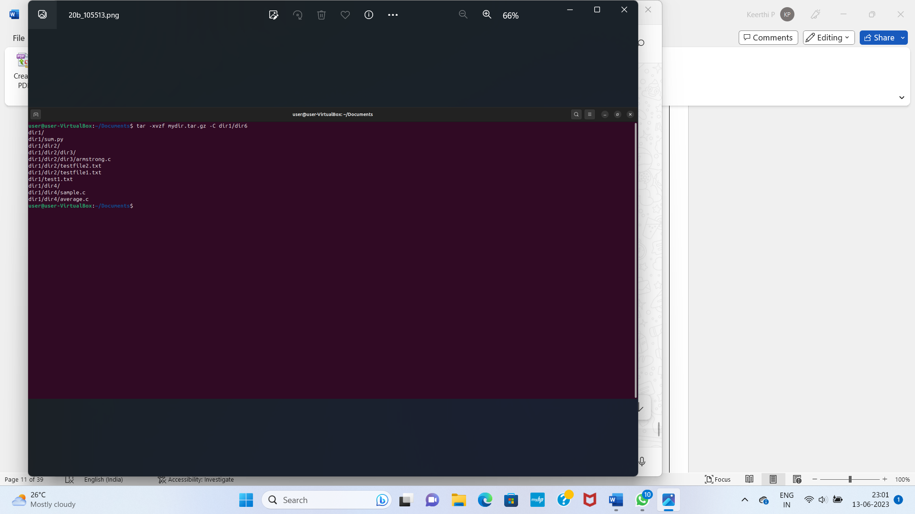

* 1. Use **top** to display processes sorted on
     1. Process id

1. Type top

2. Press N

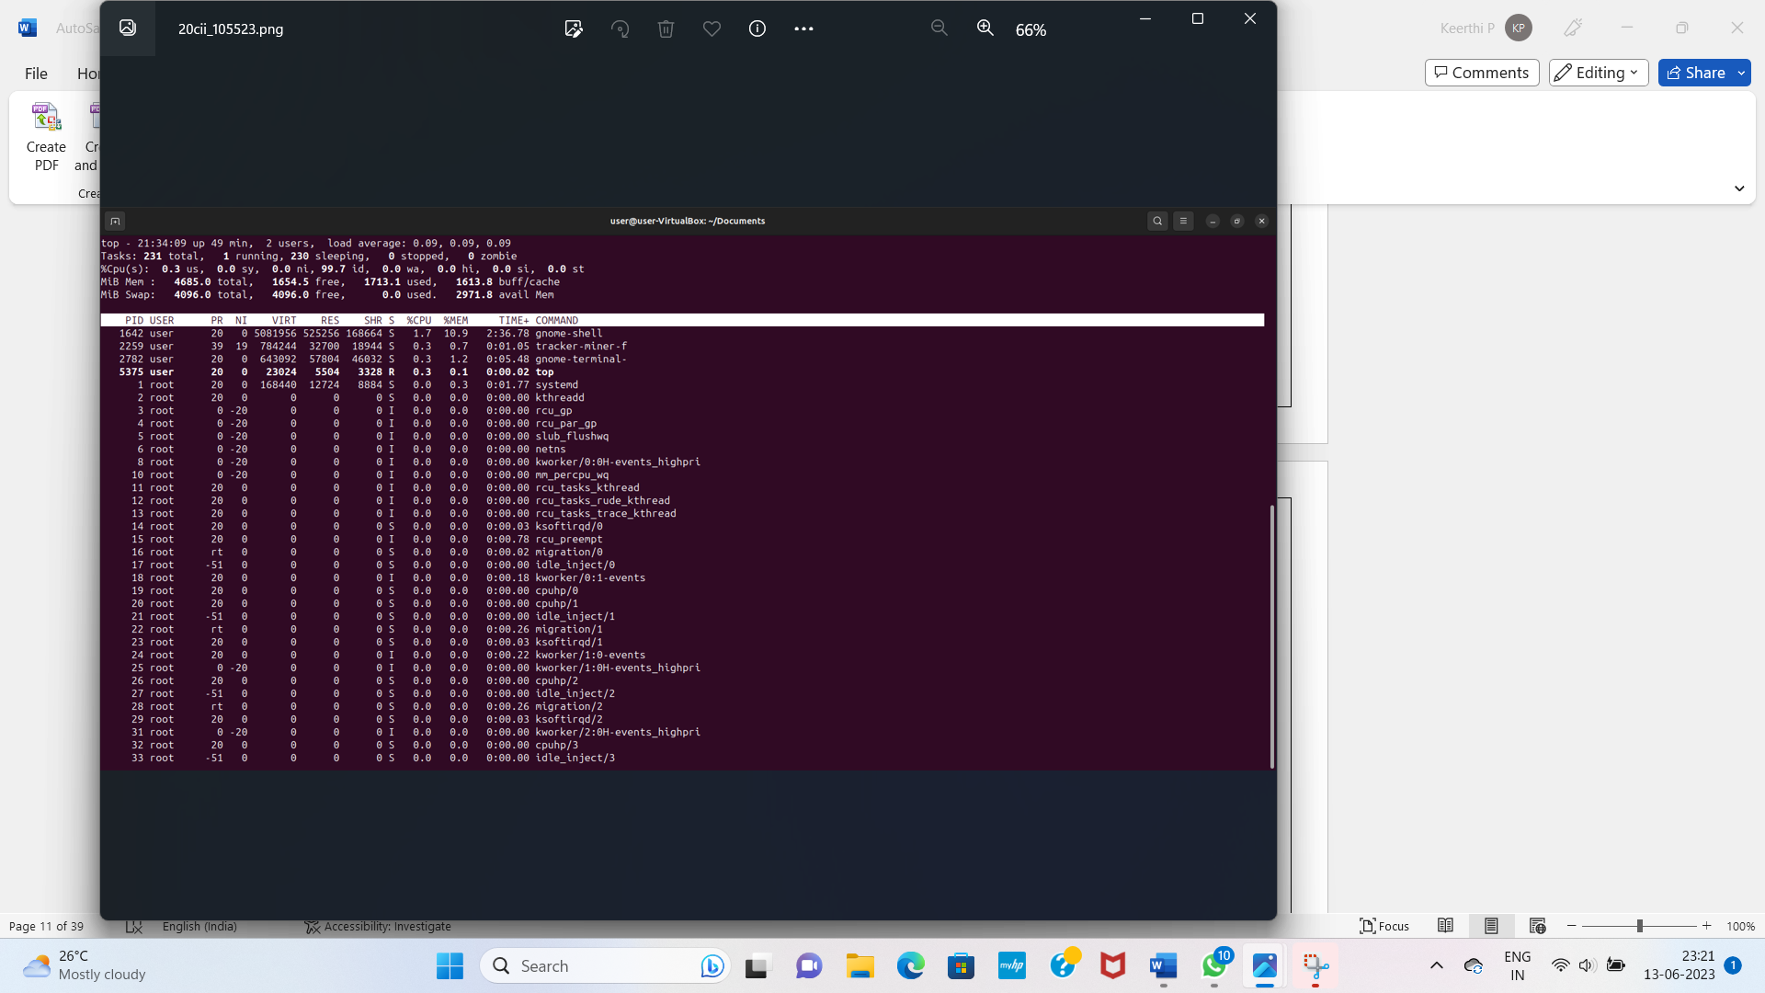

ii.CPU%

1. Type top

2. Press P

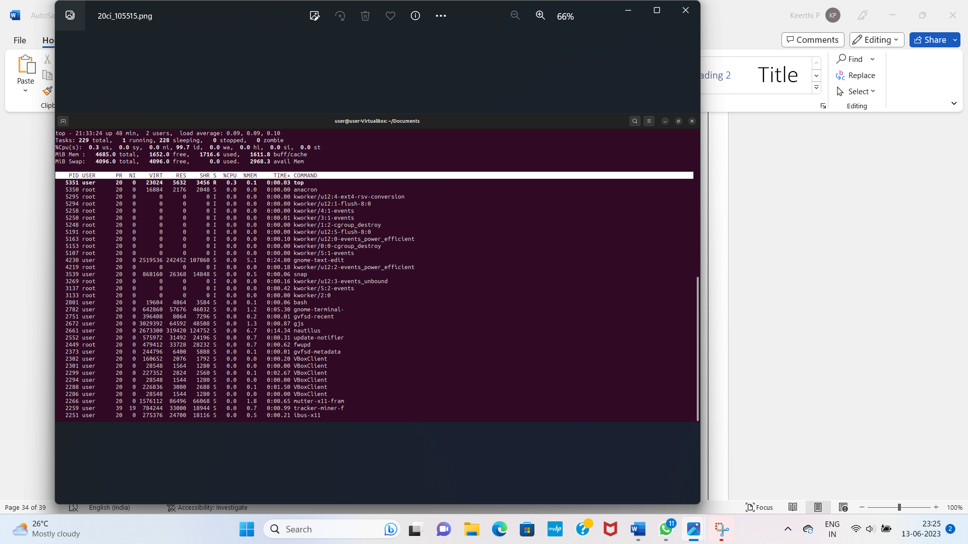

* 1. Use **ps** to display
     1. Processes associated with the current terminal.
     2. All processes in the system.

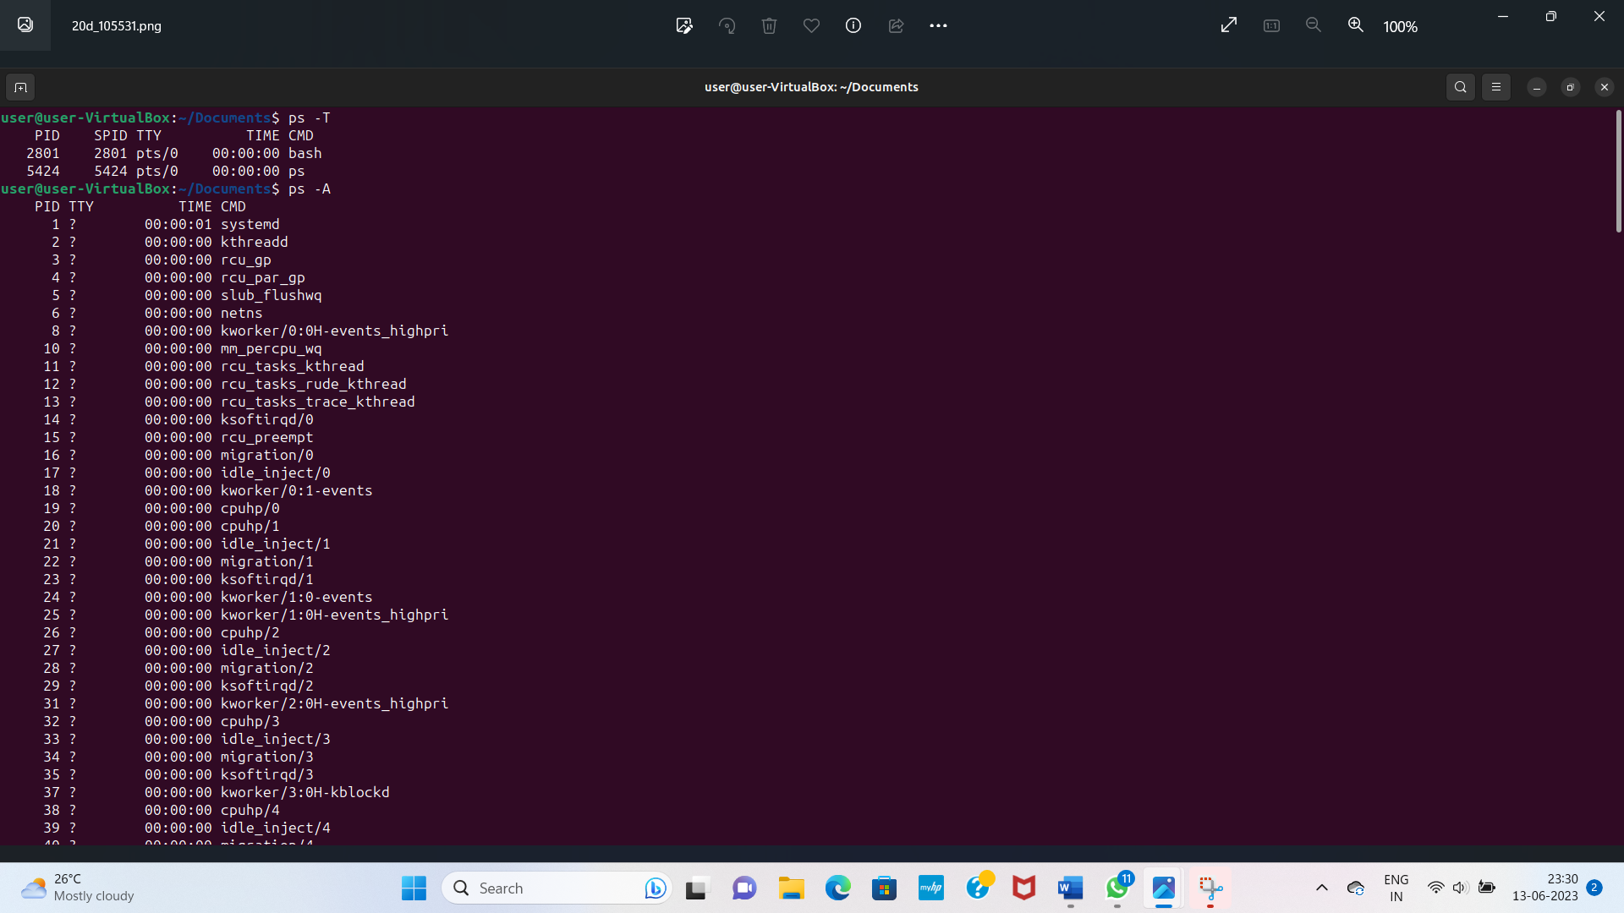

* 1. Use **df** to display the storage available in each partition in human readable form.

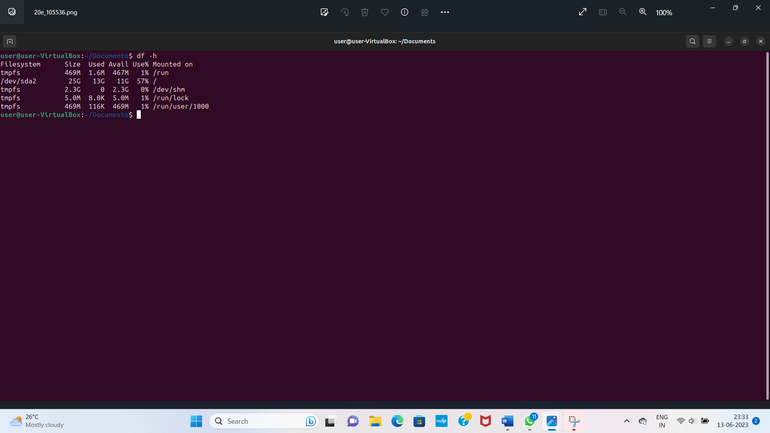

**Result:**

Commands executed successfully and output is verified.

**LAB CYCLE:3**

**EXPERIMENT NO: 5**

**Date:**

**FILE SYSTEM HIERARCHY, PERMISSION, CONFIGURATION FILES AND LOG FILES**

**Aim:** a) File system hierarchy in a common Linux distribution,

b) File and device permissions,

c) Study of system configuration files in /etc,

d) Familiarizing log files for system events, user activity,network events.

**a) File system hierarchy in a common Linux distribution**

The Linux File Hierarchy Structure or the File System Hierarchy Standard (FHS) defines the directory structure and directory contents in Unix-like operating systems. It is maintained by the Linux Foundation. In the FHS, all files and directories appear under the root directory /, even if they are stored on different physical or virtual devices.

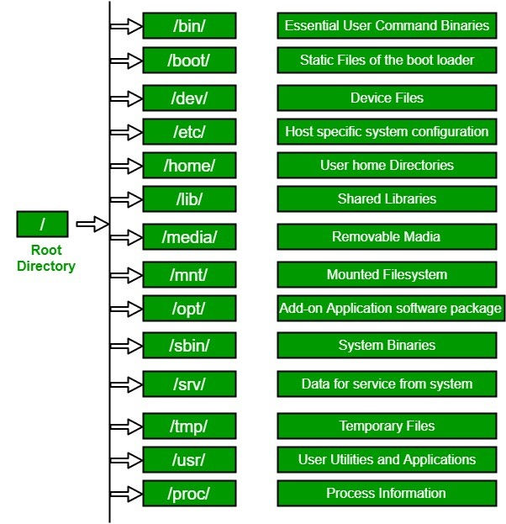

1. The Root Directory

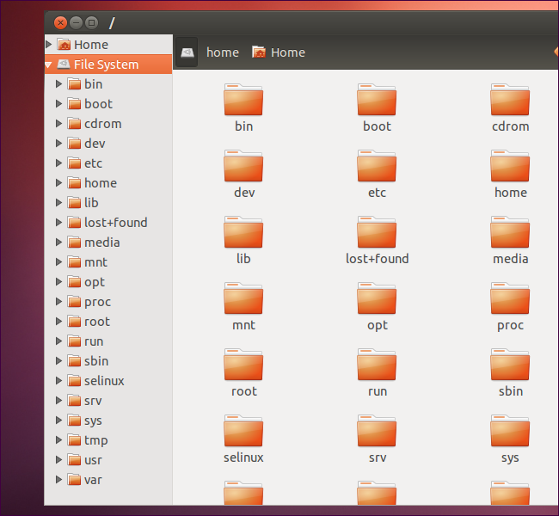

* Every single file and directory starts from the root directory.
* The only root user has the right to write under this directory.
* /root is the root user’s home directory, which is not the same as /.

2. /bin- User binaries

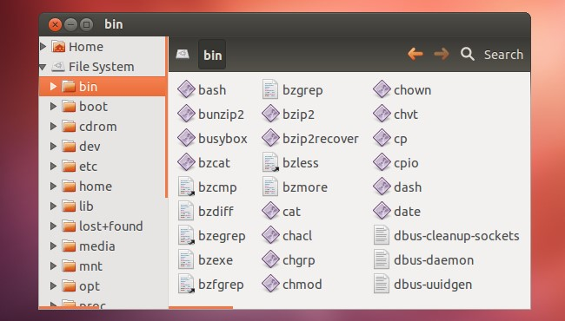

* Contains binary executables
* Common Linux commands you need to use in single-user modes are located under this directory.
* Commands used by all the users of the system are located here

e.g. ps, ls, ping, grep, cp, cat, ls.

3. /boot – Static Boot Files

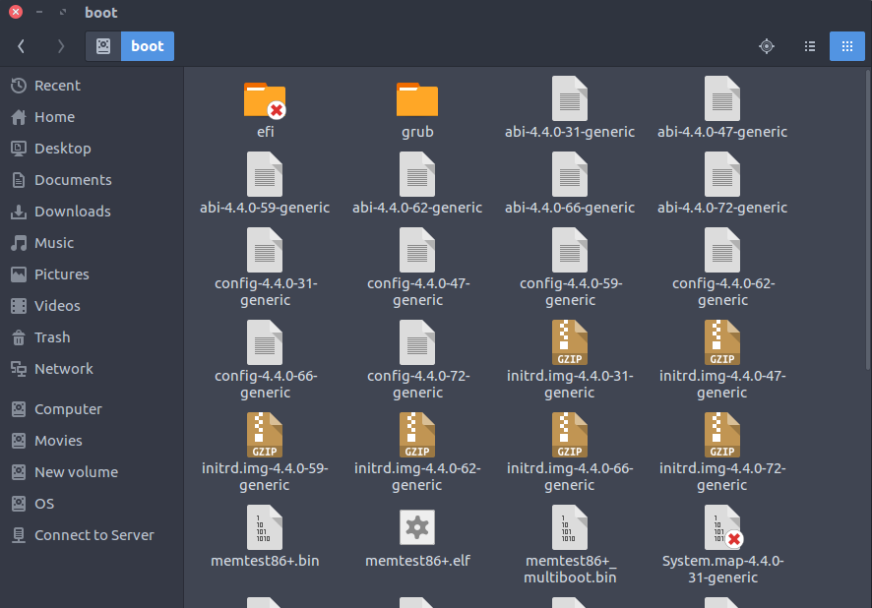

* Boot loader files
* Kernel initrd, vmlinux, grub files are located under /boot

Example: initrd.img-2.6.32-24-generic, vmlinuz-2.6.32-24-generic

4. /dev-Device Files

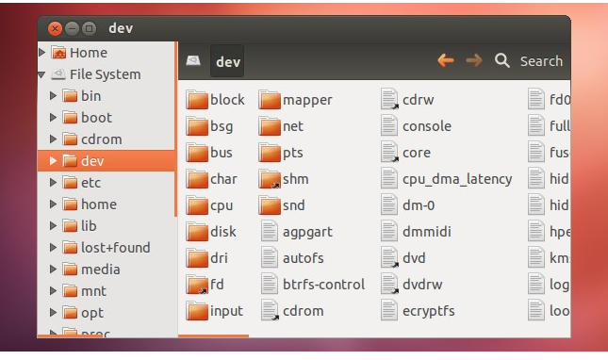

* Contains device files
* These include terminal devices, usb, or any device attached to the system.
* These are not actual files as we know them, but they appear as files – for example, /dev/sda represents the first SATA drive in the system. If you wanted to partition it, you could start a partition editor and tell it to edit /dev/sda.
* This directory also contains pseudo-devices, which are virtual devices that don’t actually correspond to hardware.

5. /etc- Configuration Files

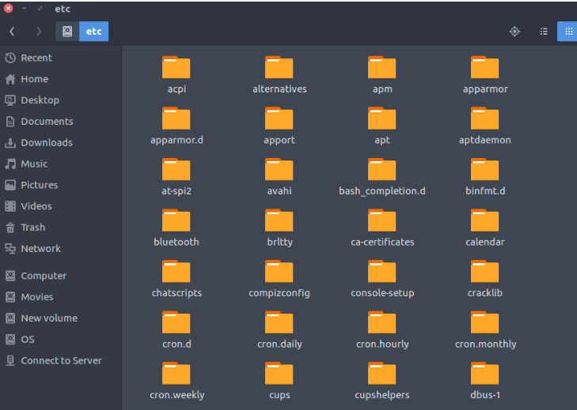

* Contains configuration files required by all programs.
* This also contains start-up and shutdown shell scripts used to start/stop individual programs.

Example: /etc/resolv.conf

**b) File and device permissions**

Since Ubuntu is a multi-user operating system, so it has security to prevent people from accessing each other’s confidential files. When you do so, each file will be listed on a separate line in a long format.

$ls -l

1. There’s a lot of information in those lines.
2. The first character = ‘-‘, which means it’s a file

‘d’, which means it’s a directory.

3. The next nine characters = (rw-r–r–) show the security

4. The next column shows the owner of the file. (Here it is `root`)

5. The next column shows the group owner of the file.

6. The next column shows the size of the file in bytes.

7. The next column shows the date and time the file was last modified.

8. Last Column = File_name or Directory_name.

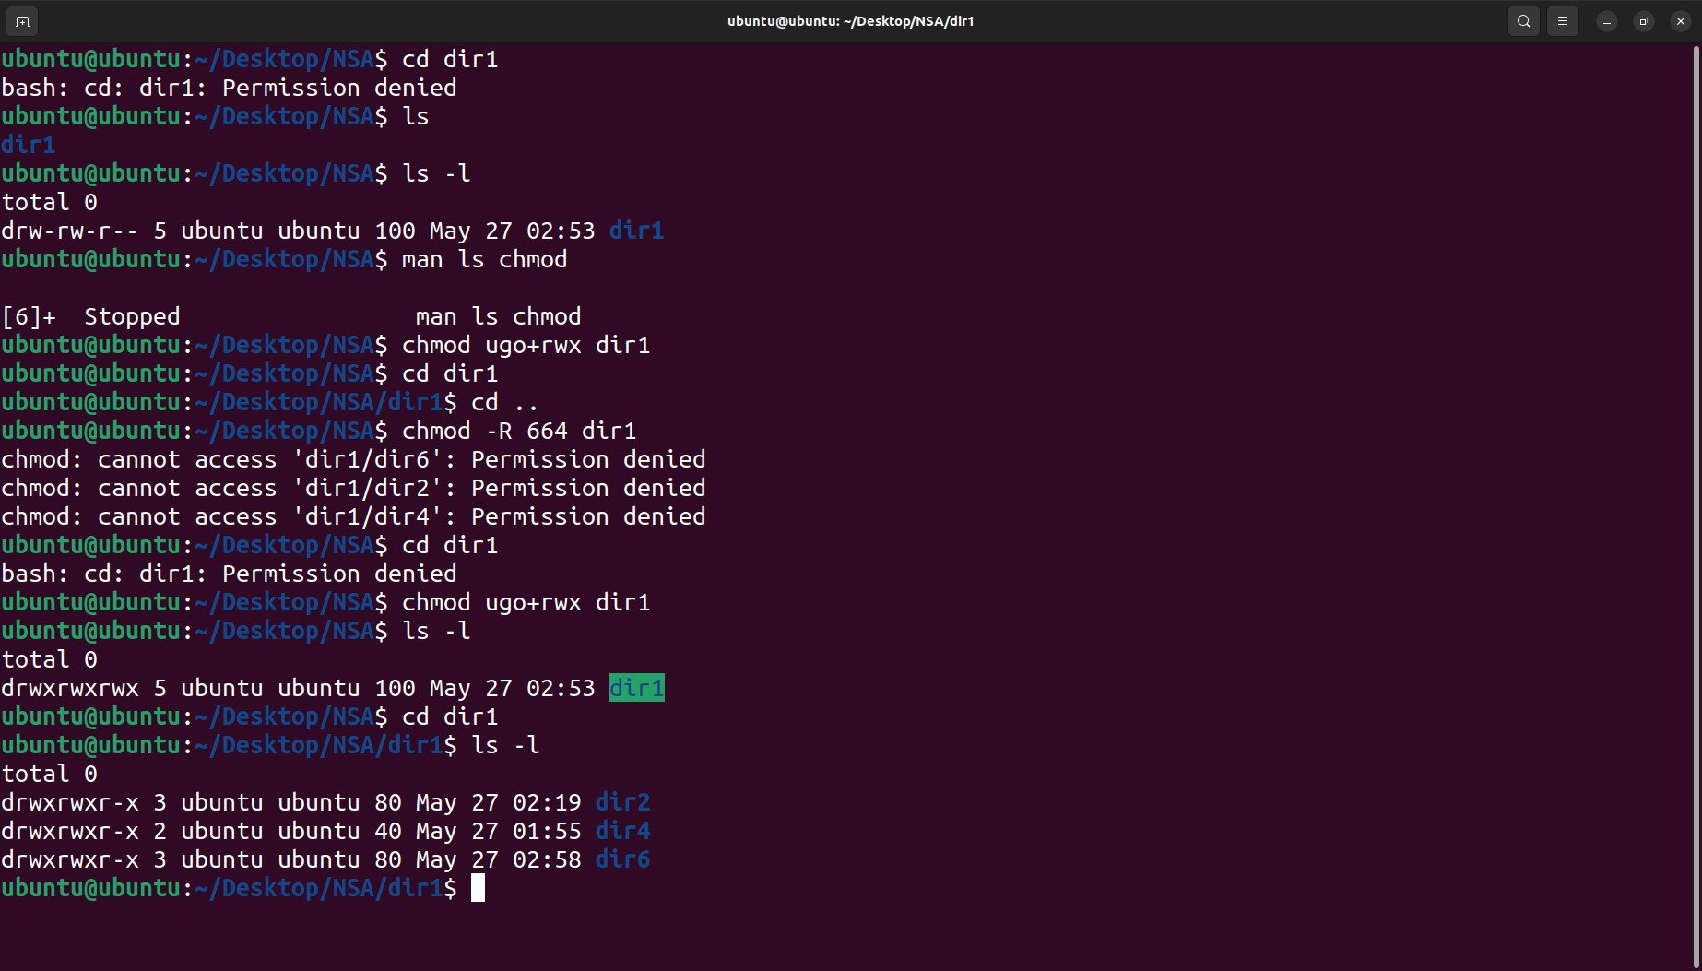

Security Permissions

rwx rwx rwx

user group other

Letters Definition

‘r’: “read” the file’s contents.

‘w’: “write”, or modify, the file’s contents.

‘x’ : “execute” the file. This permission is given only if the file is a program.

Operators Definition

`+`: Add permissions

`-`: Remove permissions

`=`: Set the permissions to the specified values

Reference Class Description

`u`(user): The user permissions apply only to the owner of the file or directory, they will not impact the actions of other users.

`g`(group): The group permissions apply only to the group that has been assigned to the file or directory, they will not affect the actions of other users.

`o`(others): The other permissions apply to all other users on the system, this is the permission group that you want to watch the most.

`a`(All three): All three (owner, groups, others)

Changing security permissions

The command you use to change the security permissions on files is called “chmod“, which stands for “change mode” because the nine security characters are collectively called the security “mode” of the file.

Adding execute permission

chmod o+x filename

Change multiple permissions at once

chmod ugo-rwx filename

Revoke execute(x) permission from others(o)

chmod ug+rw,o-x filename

Octal values

When Linux file permissions are represented by numbers, it's called numeric mode. In numeric mode, a three-digit value represents specific file permissions (for example, 744.) These are called octal values. The first digit is for owner permissions, the second digit is for group permissions, and the third is for other users. Each permission has a numeric value assigned to it:

r (read): 4

w (write): 2

x (execute): 1

In the permission value 744, the first digit corresponds to the user, the second digit to the group, and the third digit to others. By adding up the value of each user classification, you can find the file permissions.

For example, a file might have read, write, and execute permissions for its owner, and only read permission for all other users. That looks like this:

Owner: rwx = 4+2+1 = 7

Group: r-- = 4+0+0 = 4

Others: r-- = 4+0+0 = 4

The results produce the three-digit value 744.

**c) Study of system configuration files in /etc**

Linux configuration files enable the Kernel to know about users, their login state, and manage file permissions and user groups. Most of the configuration files in Linux are usually under the /etc folder./etc(et-see) directory is where a linux configuration file live. The configuration files are static and cannot be executable. They are used to control the operation of various Linux programs.

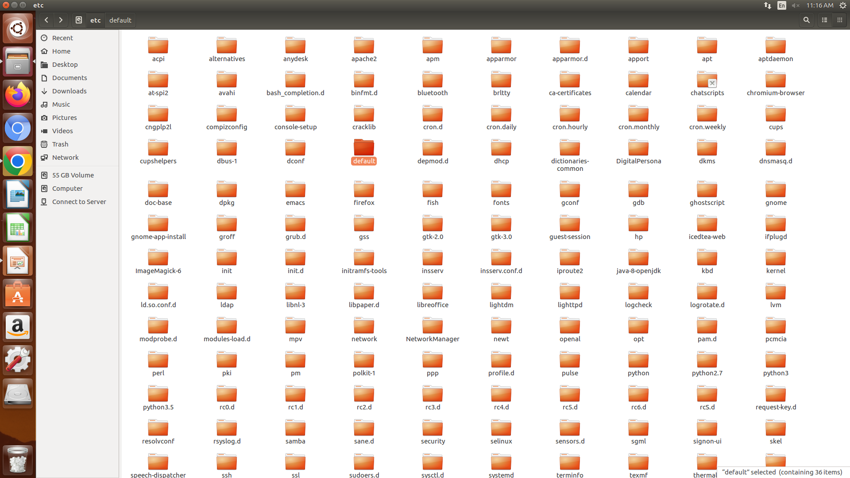

Types of Configuration Files in /etc

1. Access files

2. Booting and login/logout

3. File system

4. System administration

5. Networking

6. System commands

7. Daemons

1. Access files

Access files tell the network domain how to look up host names.

Access files include:

* /etc/hosts.config
* /etc/hosts
* /etc/hosts.allow
* /etc/hosts.deny

2. Booting and login/logout

These files contain configuration information for booting up the system.

/etc/issue & /etc/issue.net

/etc/rc.d/rc

/etc/rc.d/rc.sysinit

/etc/rc.d/rc/rc X.d

3. File system

Linux provides /proc, a virtual file system that can be used to display various system data structures and parameters.

Many programs access this file system to gain statistical information about the system, such as the devices mounted on the system, the memory usage, etc.

/etc/mtab

/etc/fstab

/etc/mtools.conf

4. System administration

This group of files contains information about the users and user groups, as well as the file permissions and credentials of all users. These files include the following configuration files:

/etc/group

/etc/nologin

/etc/passwd

/etc/securetty

/etc/shadow

5. Networking

/etc/networks

Lists names and addresses of networks accessible from the network to which the machine is connected. Used by route command. Allows use of name for network.

/etc/protocols

Lists the currently available protocols

/etc/services

Translates network service names to port number/protocol.

6. System commands

System commands are meant to be used exclusively by the system. Programs like login or bash are all system commands. These are important files containing information about the system commands and include the following files.

/etc/lilo.conf

/etc/logrotate.conf

/etc/ld.so.conf

/etc/inittab

/etc/termcap

7. Daemons

Daemons are programs that run in the background without user interference.

These are often related to networking stacks, where they wait for connections to arrive so that they can provide services through them.

/etc/syslogd.conf

​*/etc/httpd.conf*

​*/etc/conf.modules*

**d) Familiarizing log files for system events, user activity,network events.**

Log files are a set of records that Linux maintains for the administrators to keep track of important events.

They contain messages about the server, including the kernel, services and applications running on it.

Linux provides a centralized repository of log files that can be located under the  /var/log directory.

When issues arise, analyzing log files is the first thing an administrator needs to do.

How can Linux Log files help

1. Troubleshooting

When something goes wrong on a Linux system, logs can help pinpoint the issue.

By examining system logs, application logs, and service logs, it’s possible to identify errors, warnings, and other messages that indicate what went wrong.

2. Diagnosing Performance Issues

System logs can help identify performance issues like memory leaks or disk I/O bottlenecks.

Examining application logs can also help identify performance issues with specific applications.

3. Monitoring System Health

Linux logs can be used to monitor system health and detect issues before they become critical.

By monitoring system logs, administrators can identify trends and patterns that could indicate a problem is brewing.

4. Compliance and Auditing

Many organizations are required to maintain logs for compliance and auditing purposes.

Linux logs can help organizations meet these requirements by providing a record of system activity.

5. Security

Linux logs are an essential tool for monitoring and detecting security issues.

System logs can be used to detect unauthorized access attempts, while application logs can help identify suspicious activity within specific applications.

By monitoring logs, administrators can quickly identify and respond to security incidents.

The log files generated in a Linux environment can typically be classified into four different categories:

* Application Logs
* Event Logs
* Service Logs
* System Logs

1. System Logs

These logs contain information about the system’s operation, such as boot messages, kernel messages, and hardware events.

System logs are essential for troubleshooting system issues, and monitoring system performance.

2. Application Logs

These logs contain information about the behaviour of an application, including errors, warnings, and other messages.

Application logs are used to diagnose problems with applications and to analyze application performance.

3. Service Logs

These logs contain information about services running on the system, including network services and daemons.

Service logs are used to monitor service activity, and optimize service performance.

4.Event Logs

These logs contain information about events on the system, such as user logins, system shutdowns, and security events.

Event logs are used to audit system activity, track user activity, and investigate security incidents

Which Linux log files to monitor?

Monitoring and analyzing all of them can be a challenging task.

The sheer volume of logs can sometimes make it frustrating just to drill down and find the right file that contains the desired information.

1. /var/log/messages

2. /var/log/auth.log

3. /var/log/secure

4. /var/log/boot.log

5. /var/log/dmesg

6. /var/log/kern.log

7. /var/log/faillog

8. /var/log/cron

9. /var/log/yum.log

10. /var/log/maillog or /var/log/mail.log

11. var/log/httpd/

12. /var/log/mysqld.log or /var/log/mysql.log

**Result:**

Familiarisation with file system hierarchy,permission, configuration files and log files has been done successfully.

**LAB CYCLE:4**

**EXPERIMENT NO: 6**

**Date:**

**SHELL SCRIPTING**

**Aim:** a) Shell scripting: study bash syntax, environment variables, variables, control constructs such as if, for and while, aliases and functions, accessing command line arguments passed to shell scripts.

b) Study of startup scripts, login and logout scripts, familiarity with systemd and system 5 init scripts is expected

a) Shell scripting: study bash syntax, environment variables, variables, control constructs such as if, for and while, aliases and functions, accessing command line arguments passed to shell scripts.

Shell scripting refers to the process of writing and executing scripts using a shell, which is a command-line interface or command interpreter on Unix-like operating systems. The most commonly used shell scripting languages are Bash (Bourne Again Shell) and sh (Bourne Shell). Shell scripts can automate tasks, execute commands, and perform various operations on a Unix or Linux system.

Here are some key concepts and features of shell scripting:

1.Script file extension: Shell scripts typically have file extensions like ".sh" to indicate that they are shell scripts.

2.Shebang line: The first line of a shell script starts with a shebang (#!) followed by the path to the shell interpreter. For example, #!/bin/bash specifies that the script should be interpreted using Bash.

3.Variables: Shell scripts can define and use variables. Variables are typically assigned values using the assignment operator (=).

For example :

name="John"

age=25

4.Command execution: Shell scripts can execute commands using various command-line utilities. Commands can be executed directly or stored in variables for later use. For example:

ls

result=$(ls)

5.Control structures: Shell scripting supports control structures like conditionals (if-else statements) and loops (for loops, while loops). These structures allow you to control the flow of execution based on conditions or iterate over a set of values.

6.Input/output redirection: Shell scripts can redirect input and output streams. For example, you can redirect the output of a command to a file using the ">" operator or read input from a file using the "<" operator.

7.Functions: Shell scripts can define functions to encapsulate reusable code blocks. Functions help in modularizing the script and improving code organization.

8.Command-line arguments: Shell scripts can accept command-line arguments. These arguments can be accessed using special variables like $1, $2, etc., where $1 represents the first argument, $2 represents the second argument, and so on.

9.Environment variables: Shell scripts can access and modify environment variables, which are system-wide variables that hold information about the environment in which the script is running.

10.Error handling: Shell scripts can handle errors using conditional statements and error codes returned by commands. This allows scripts to take appropriate actions based on the success or failure of commands.

Shell scripting is a powerful tool for automation, system administration, and repetitive tasks in Unix-like operating systems. It provides a flexible and efficient way to execute commands, manipulate data, and control the behavior of the shell.

**Environment Variables**

Environment variables are an essential part of shell scripting as they allow you to store and retrieve information that can be used by various processes and scripts running in the shell. Here are some key points about environment variables in shell scripting:

1. Defining Environment Variables: Environment variables are typically defined using uppercase letters. To set an environment variable, you can use the export command followed by the variable name and its value. For example:

export MY_VAR="Hello, World!"

2. Accessing Environment Variables: To access the value of an environment variable, you can use the $ symbol followed by the variable name. For example:

echo $MY_VAR

3. System-defined Environment Variables: The shell automatically sets some environment variables that contain useful information. Examples include:

$HOME: The current user's home directory.

$PATH: A list of directories where the shell looks for executable files.

$USER: The username of the current user.

$PWD: The present working directory.

4. Shell Script-defined Environment Variables: You can define your own environment variables within shell scripts. These variables are local to the script by default, but you can export them to make them available to other processes. For example:

# Define a local variable

MY_LOCAL_VAR="Local variable"

# Export the variable to make it available to other processes

export MY_LOCAL_VAR

5. Using Environment Variables in Scripts: Environment variables can be used within shell scripts just like any other variables. Here's an example:

#!/bin/bash

echo "The value of MY_VAR is: $MY_VAR"

6. Unsetting Environment Variables: To remove an environment variable, you can use the unset command followed by the variable name. For example:

unset MY_VAR

7. Persistent Environment Variables: Environment variables defined in a shell session are not persistent and will be lost when the session ends. To make them persistent, you can define them in shell startup files such as .bashrc or .bash_profile (for Bash) or in the system-wide /etc/environment file.

**Variables**

Variables in shell scripting are used to store and manipulate data within a script. Here are some important points about variables in shell scripting:

1. Variable Declaration: In shell scripting, variables are typically declared without specifying a data type. You can assign a value to a variable using the syntax variable_name=value. For example:

name="John"

age=25

2. Variable Naming: Variable names in shell scripting can contain letters (a-z, A-Z), digits (0-9), and underscores (_). They must start with a letter or an underscore. Variable names are case-sensitive, so my_var and MY_VAR are considered different variables.

3. Accessing Variable Values: To access the value of a variable, you can use the $ symbol followed by the variable name. For example:

echo $name

4. Variable Scope: By default, variables in shell scripts have a global scope and can be accessed from anywhere within the script. If you want to limit the scope of a variable to a specific block of code, you can use functions.

5. Special Variables: Shell scripting provides some predefined variables that have special meanings. Examples include:

$0: The name of the script itself.

$1, $2, etc.: Command-line arguments passed to the script.

$#: The number of command-line arguments.

$?: The exit status of the last command.

$$: The process ID of the current script.

6. Variable Manipulation: You can perform various operations on variables, such as concatenation, substring extraction, and arithmetic calculations. Some commonly used operators and syntax include:

Concatenation: result=$var1$var2

Substring extraction: substring=${string:position:length}

Arithmetic calculations: result=$((num1 + num2))

7. Quoting Variables: When accessing variable values, it's a good practice to enclose them in double quotes ("") to handle cases where the value contains spaces or special characters. For example:

echo "$name is $age years old."

8. Variable Assignment from Command Output: You can assign the output of a command to a variable using command substitution. The syntax is variable=$(command). For example:

date=$(date +%Y-%m-%d)

These are some fundamental aspects of variables in shell scripting. They allow you to store and manipulate data, perform calculations, and pass information to and from your script.

**Control Structures**

In shell scripting, control structures are used to control the flow of execution based on certain conditions or to repeat a set of instructions. The commonly used control structures in shell scripting include:

1. if-else: The if-else statement allows you to perform different actions based on a condition. It has the following syntax:

if condition

then

# statements to execute if condition is true

else

# statements to execute if condition is false

fi

2. for loop: The for loop allows you to iterate over a list of values or elements. It has the following syntax:

for variable in list

do

# statements to execute for each iteration

done

The variable takes the value of each item in the list on each iteration.

3. while loop: The while loop allows you to repeat a set of statements as long as a condition is true. It has the following syntax:

while condition

do

# statements to execute while condition is true

done

The loop continues until the condition evaluates to false.

4. until loop: The until loop is similar to the while loop, but it continues until a condition becomes true. It has the following syntax:

until condition

do

# statements to execute until condition becomes true

done

The loop continues until the condition evaluates to true.

5. case statement: The case statement allows you to perform different actions based on the value of a variable. It has the following syntax:

case variable in

pattern1)

# statements to execute for pattern1

;;

pattern2)

# statements to execute for pattern2

;;

pattern3)

# statements to execute for pattern3

;;

*)

# statements to execute for all other patterns

;;

esac

The value of variable is compared against each pattern, and the corresponding statements are executed for the matching pattern.

These control structures provide you with the flexibility to conditionally execute code, iterate over a set of values, and make decisions based on different conditions in shell scripting.

**Aliasing**

In Linux, an alias is a shortcut that references a command. An alias replaces a string that invokes a command in the Linux shell with another user-defined string. Aliases are mostly used to replace long commands, improving efficiency and avoiding potential spelling errors.

The alias command provides a string value that replaces a command name when it is encountered. The alias command lets you create shortcuts for long commands, making them easier to remember and use. It will have the same functionality as if the whole command is run.

How to Create Your Own Linux Commands?

Using the alias command, you'll be able to create your own commands. It's so simple to create your own command.

Here's the syntax for the alias command:

alias [alias-name[=string]...]

Let's look at an example of creating your own command.

Let's assume you want to create a command called cdv, and entering the command in the terminal should take you to the Videos directory.

Usually, to navigate to a directory, we use cd command. To navigate to Videos we need to use cd Videos as shown in the below screenshot:



Let's create our command called cdv to navigate to the Videos directory. To achieve that, you have to enter the following command in your terminal:

alias cdv="cd Videos“



We have created our command. From the above screenshot, you can see that it does not return anything.

Run the cdv command on your terminal to see what happens:



How to View Created Alias Commands

You can view all your alias commands by appending the -p flag to the alias command like this:

*alias -p*

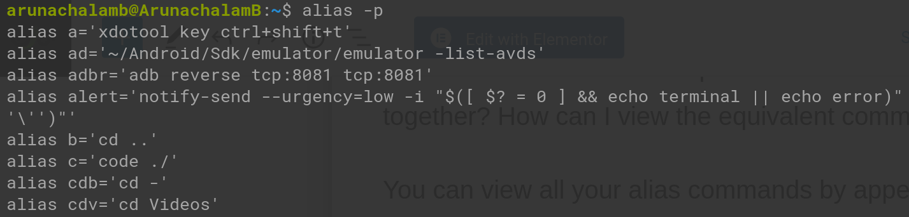

How to Remove an Alias Command in Linux

Pass your alias name to the unalias command as an argument to remove the alias command.

*unalias alias_name*

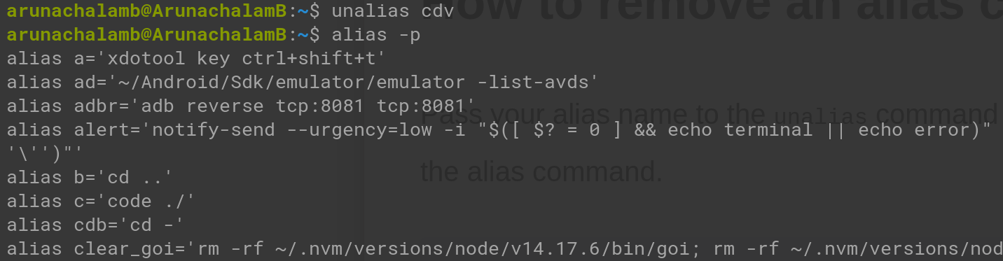

How to Remove All Alias Commands in Linux

We have a command to achieve that:

*unalias –a*

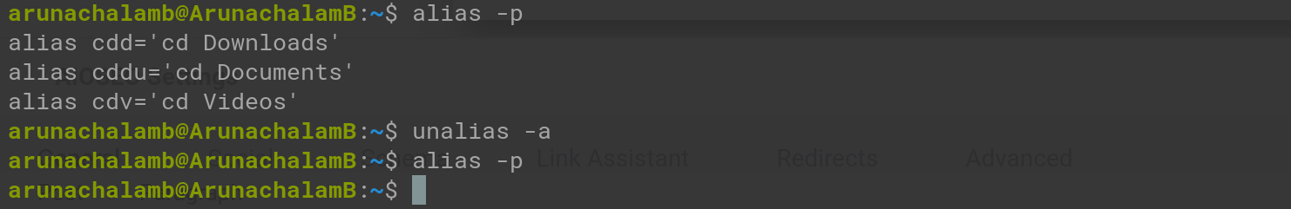

If you create an alias command, it'll be active only for the particular instance of the terminal. It'll not be created permanently, so you won't be able to access it in two different terminal windows unless you run the alias command on both terminals.

b) Study of startup scripts, login and logout scripts, familiarity with systemd and system 5 init scripts is expected

Startup scripts, login scripts, and logout scripts are important components of the initialization process in a Unix-like operating system. They allow administrators to automate tasks and configure system behavior during system startup, user login, and user logout. Familiarity with systemd and System V init scripts is crucial for managing these processes efficiently. Let's explore each of these topics in more detail:

1. Startup Scripts:

Startup scripts are executed during the boot process to initialize the system. In modern Linux distributions that use systemd as the init system, startup scripts are typically managed through systemd unit files. These unit files define services, targets, and other units that control the behavior of the system. The main directory for systemd unit files is /etc/systemd/system/.

2. Login Scripts:

Login scripts are executed when a user logs into a system. These scripts provide a way to set environment variables, configure user-specific settings, and perform additional tasks upon login. The specific login script executed depends on the user's shell and the system configuration. For example, in the Bash shell, the login script is usually ~/.bash_profile or ~/.bash_login for login shells, and ~/.bashrc for non-login shells.

3. Logout Scripts:

Logout scripts are executed when a user logs out of a system. These scripts allow for cleanup tasks, such as removing temporary files or logging session statistics. The specific logout script executed depends on the user's shell and the system configuration. In Bash, the logout script is typically ~/.bash_logout.

4. Systemd:

Systemd is a modern init system and service manager that has replaced the traditional System V init system in many Linux distributions. Systemd provides enhanced features for managing services, including parallel startup, dependency-based service control, and centralized logging. Systemd unit files, such as service unit files (.service), target unit files (.target), and timer unit files (.timer), are used to define and control services.

5. System V Init Scripts:

System V init scripts were the traditional initialization mechanism used in Unix-like systems before the introduction of systemd. Init scripts are stored in /etc/init.d/ directory and are typically written in shell scripting languages (e.g., Bash). These scripts are responsible for starting, stopping, and managing system services and can be run manually or automatically during the system startup.

Familiarity with both systemd and System V init scripts is important for understanding and managing the initialization process in different Linux distributions. The choice of which init system to use depends on the specific distribution and its configuration. It's beneficial to have knowledge of both to be able to work with various systems effectively.

**Shell script program questions.**

1. Write a script to show current date,time and current directory.

#!/bin/bash

echo "Current date is `date`"

echo "Current directory is `pwd`"

**Output:**

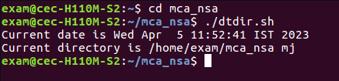



2.Write shell script to find reverse of a number.

#!/bin/bash

echo enter the no:

read n

num=0

while [ $n -gt 0 ]

do

num=$(expr $num \* 10)

k=$(expr $n % 10)

num=$(expr $num + $k)

n=$(expr $n / 10)

done

echo Reversed number is $num

**Output:**

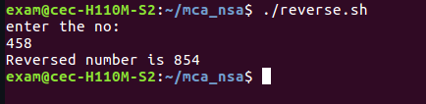

3. Write a script to find largest among three numbers.

#!/bin/bash

echo Enter the 1st no:

read m

echo Enter the 2nd no:

read n

echo Enter the 3rd no:

read o

if [ $m -gt $n ] && [ $m -gt $o ]

then

echo Largest is $m

elif [ $n -gt $m ] && [ $n -gt $o ]

then

echo Largest is $n

else

echo Largest is $o

fi

**Output:**

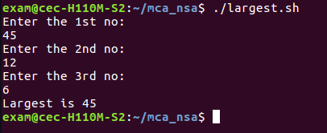

4. Write a script to check whether a number is armstrong or not.

#!/bin/bash

echo "Enter a number: "

read c

x=$c

sum=0

r=0

n=0

while [ $x -gt 0 ]

do

r=`expr $x % 10`

n=`expr $r \* $r \* $r`

sum=`expr $sum + $n`

x=`expr $x / 10`

done

if [ $sum -eq $c ]

then

echo "It is an Armstrong Number."

else

echo "It is not an Armstrong Number."

fi

**Output:**

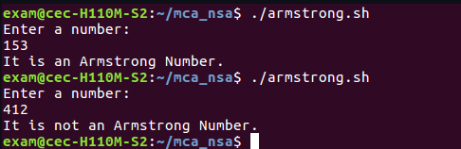

5. Write a script to check password and login.

# !/bin/bash

read -p 'Username: ' user

read -sp 'Password: ' pass

if (( $user == "Admin" && $pass == "admin123" ))

then

echo -e "\nWelcome! You are Sucessfull login\n"

else

echo -e "\nUnsuccessful login\n"

fi

**Output:**

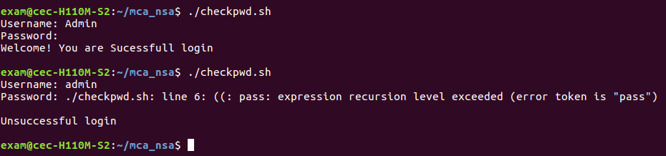

6. Write a script to count the prime numbers in specific range

#!/bin/bash

echo "Enter a lower limit"

read i

echo "Enter a upper limit"

read limit

echo "prime numbers upto $limit are :"

while [ $i -le $limit ]

do

flag=1

j=2

while [ $j -lt $i ]

do

rem=$(( $i % $j ))

if [ $rem -eq 0 ]

then

flag=0

break

fi

j=$(( $j+1 ))

done

if [ $flag -eq 1 ]

then

echo "$i"

fi

i=$(( $i+1 ))

done

**Output:**

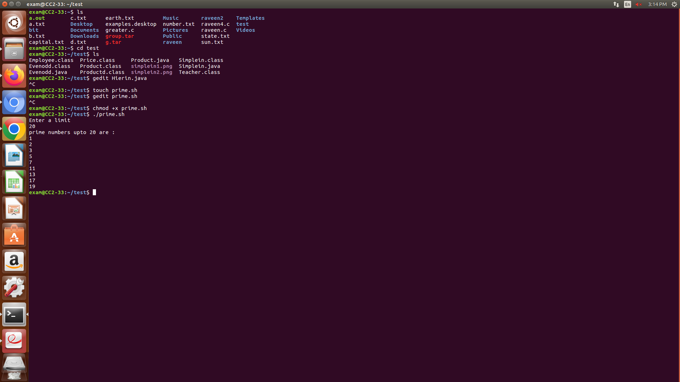

7. Write a script to convert the contents of agiven file from uppercase to lowercase and also

count the number of lines,words and characters of the resultant file. Also display the resultant

file in descending order.

#!/bin/bash

getFile()

{

# Reading txtFileName to convert it's content

echo -n "Enter File Name:"

read filename

# Checking if file exist

if [ ! -f $filename ]; then

echo "File Name $filename does not exists."

exit 1

fi

}

echo "1. Uppercase to Lowercase "

echo "2. Count the number of characters,words,lines"

echo "3. Exit "

echo -n "Enter your Choice(1-3):"

read ch

case "$ch" in

1)

# Function Call to get File

getFile

# Converting to lower case if user choose 1

echo "Converting Upper-case to Lower-Case "

tr '[A-Z]' '[a-z]' <$filename

;;

2)

echo Enter the filename

read file

c=`cat $file | wc -c`

w=`cat $file | wc -w`

l=`grep -c "." $file`

echo Number of characters in $file is $c

echo Number of words in $file is $w

echo Number of lines in $file is $l

;;

*) # exiting for all other cases

echo "Exiting..."

exit

;;

esac

**Output:**

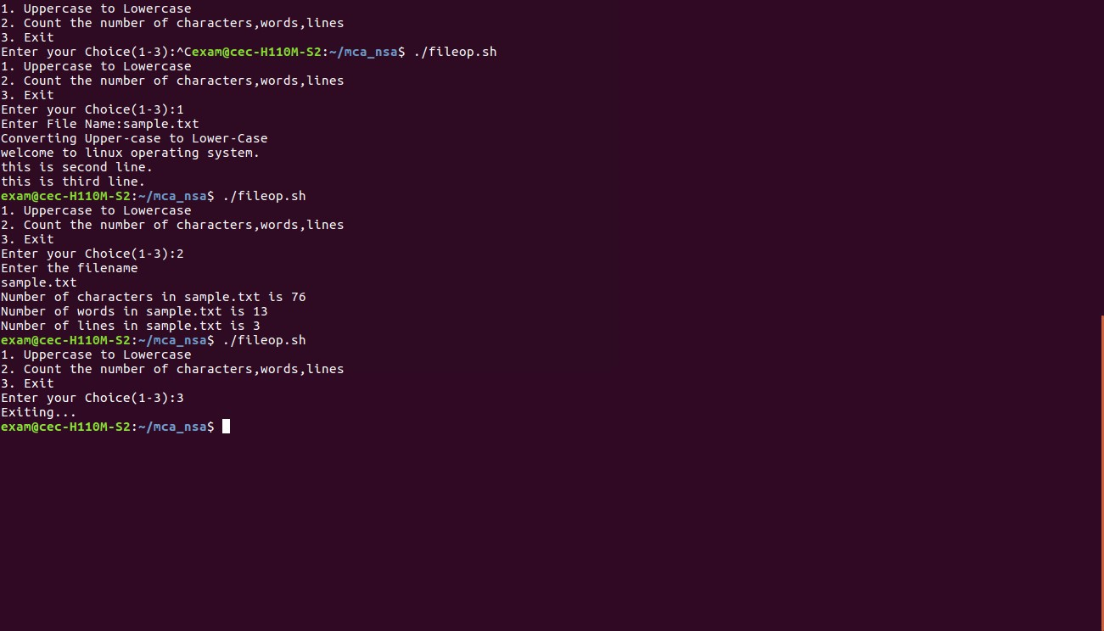

8. Write a script to perform following basic math operation as:

Addition, subtraction, multiplication, division

#!/bin/sh

echo "Enter the two numbers to perform arithmetic operations "

read a b

val=`expr $a + $b`

echo "a + b : $val"

val=`expr $a - $b`

echo "a - b : $val"

val=`expr $a \* $b`

echo "a * b : $val"

if [ $a -gt $b ]

then

val=`expr $a / $b`

echo "a / b : $val"

else

val=`expr $b / $a`

echo "b / a : $val"

fi

**Output:**

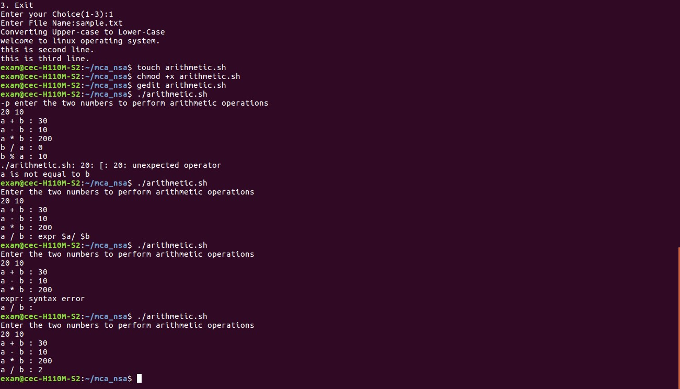

9. Read 3 marks of a student and find the average. Display the grade of the student based on

the average. (if..then..elif..fi)

S >= 90%

A < 90%, but >= 80%

B < 80%, but >= 60%

P < 80%, but >= 40%

F < 40%

#! /bin/bash

read -p "Enter three marks out of 100 each : " m1 m2 m3

s=$(($m1+$m2+$m3))

avg=$(($s / 3|bc))

echo -e "Average: $avg"

if [ $avg -ge 90 ]

then

echo "Grade: S"

elif [[ $avg -lt 90 && $avg -ge 80 ]]

then

echo "Grade: A"

elif [[ $avg -lt 80 && $avg -ge 60 ]]

then

echo "Grade: B"

elif [[ $avg -lt 80 && $avg -ge 40 ]]

then

echo "Grade: P"

else

echo "Grade: F"

fi

**Output:**

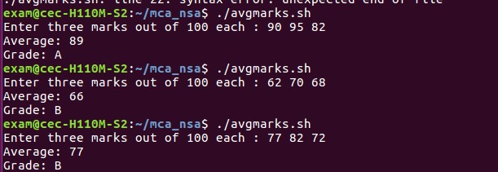

10. Read the name of an Indian state and display the main language according to the table. For other states, the output may be “Unknown”. Use “|” to separate states with same language *(case..esac)*

|  |  |
| --- | --- |
| State | Main Language |
| Andhra Pradesh | Telugu |
| Assam | Assamese |
| Bihar | Hindi |
| Himachal Pradesh | Hindi |
| Karnataka | Kannada |
| Kerala | Malayalam |
| Lakshadweep | Malayalam |
| Tamil Nadu | Tamil |

#!/bin/bash

echo -e "1.andhra pradesh \n2.assam \n3.bihar \n4.karnataka \n5.kerala \n6.tamil nadu \n7.Exit"

read -p "Enter the Indian state: " state

#state=$(echo $state | tr '[:upper:]' '[:lower:]')

case $state in

1)

echo "Language: Telugu"

;;

2)

echo "Language: Assamese"

;;

3)

echo "Language: Hindi"

;;

4)

echo "Language: Kannada"

;;

5)

echo "Language: Malayalam"

;;

6)

echo "Language: Tamil"

;;

*)

echo "Language: Unknown";;

esac

**Output:**



11.Change the home folder of all users whose name start with stud from /home/username to

/usr/username. Also change the password of username to username123 (e.g., /home/stud25

changes to /usr/stud25 and his/her password changes to stud25123) - (Use for .. in)

#! /bin/bash

result=$(grep stud* /etc/passwd)

result=$(echo "${result}"| cut -d: -f 1)

echo $result

for f in $result

do

p="${f}123"

sudo usermod -p $(echo $p | openssl passwd -1 -stdin) $f

sudo usermod -m -d /usr $f

done

**Output:**







12. Read a number and display the multiplication table of the number up to 10 lines. -

(Use for((..)))

#! /bin/bash

read -p "Enter a number: " num

echo "Multiplication table of $num : "

for (( i=1; i<=10; i++))

do

val=$(( num * i ))

echo "$i * $num = $val"

done

**Output:**

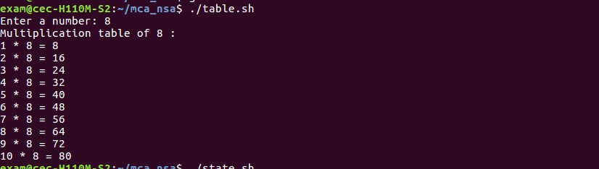

13. Read a Decimal number. Convert it to Binary and display the result. -

(Use while)

#! /bin/bash

read -p "Enter a decimal number: " n

val=0

power=1

while [ $n -ne 0 ]

do

r=`expr $n % 2`

val=`expr $r \* $power + $val`

power=`expr $power \* 10`

n=`expr $n \/ 2`

done

echo "Binary equivalent : $val"

**Output:**



**Result:**

Shell script program has done successfully and output is verified.

1.Look at the system log files. Write a shell script to extract the last login details of a particular user and list out all failed logins. Store the results to a file. The user name should be given as a command line argument.

**Command:** ./logfile.sh

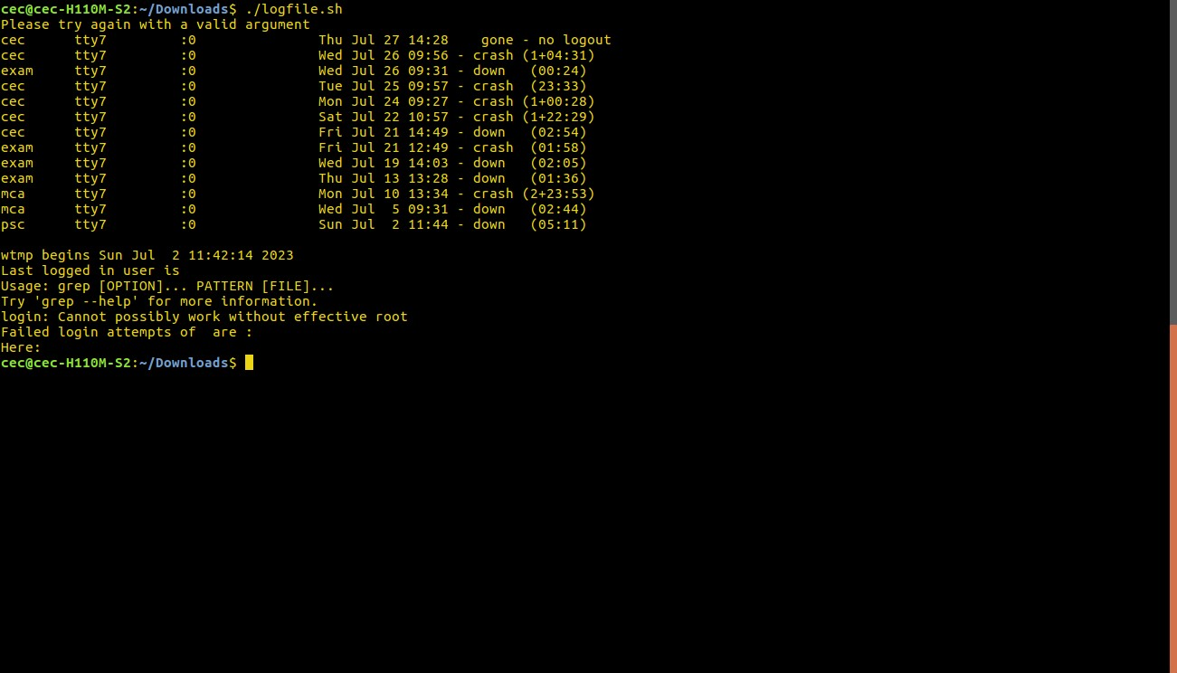

2.Write a shell script to display the details of a particular process currently running. Assume that you have necessary permissions. The process name/id is to be given as a command line argument.

**Command:** ps

./runningps.sh 2912

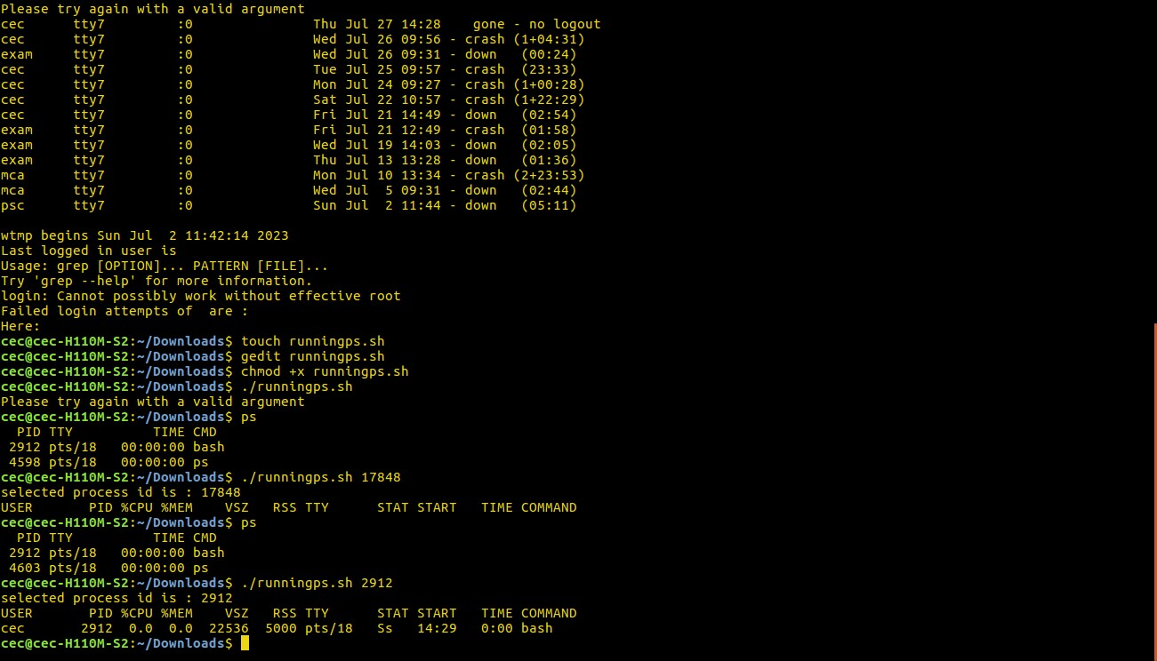

**LAB CYCLE:5**

**EXPERIMENT NO:7**

**Date:**

**Aim:** Networking- IPv4 networking, network commands: ping route traceroute, nslookup, ip. Setting up static and dynamic IP addresses. Concept of Subnets, CIDR address schemes, Subnet masks,iptables, setting up a firewall for LAN, Application layer (L7) proxies.

**IPv4 networking**

IP stands for Internet Protocol and v4 stands for Version Four (IPv4). IPv4 was the primary version brought into action for production within the ARPANET in 1983. IP version four addresses are 32-bit integers which will be expressed in decimal notation.

Parts of IPv4

* Network part: The network part indicates the distinctive variety that’s appointed to the network. The network part conjointly identifies the category of the network that’s assigned.
* Host Part: The host part uniquely identifies the machine on your network. This part of the IPv4 address is assigned to every host. For each host on the network, the network part is the same, however, the host half must vary.
* Subnet number: This is the nonobligatory part of IPv4. Local networks that have massive numbers of hosts are divided into subnets and subnet numbers are appointed to that.

Characteristics

* IPv4 could be a 32-Bit IP Address.
* IPv4 could be a numeric address, and its bits are separated by a dot.
* The number of header fields is twelve and the length of the header field is twenty.
* It has Unicast, broadcast, and multicast style of addresses.
* IPv4 supports VLSM (Virtual Length Subnet Mask).
* IPv4 uses the Post Address Resolution Protocol to map to the MAC address.
* RIP may be a routing protocol supported by the routed daemon.
* Networks ought to be designed either manually or with DHCP.
* Packet fragmentation permits from routers and causing host.

Some key points about IPv4 networking:

1. Addressing: IPv4 addresses are expressed as four sets of numbers separated by periods, such as 192.168.0.1. Each set represents 8 bits, resulting in a range of 0 to 255 for each set. This gives a total of 2^32 (around 4.3 billion) unique addresses.

2. Classes: IPv4 initially defined three address classes: A, B, and C. Each class had a different range of available addresses, with Class A providing a large number of network addresses but fewer host addresses, and Class C offering a smaller number of network addresses but more host addresses. Later, Classless Inter-Domain Routing (CIDR) was introduced to allow more flexible allocation of IP addresses.

3. Subnetting: Subnetting is the practice of dividing a network into smaller subnetworks or subnets. It allows organizations to efficiently allocate IP addresses by creating smaller networks within a larger network. Subnetting involves borrowing bits from the host portion of an IP address to create a separate network identifier and subnet identifier.

4. Private IP Addresses: Certain IP address ranges are reserved for private networks, which are not directly accessible from the public Internet. The most commonly used private IP address ranges are:

Class A: 10.0.0.0 to 10.255.255.255

Class B: 172.16.0.0 to 172.31.255.255

Class C: 192.168.0.0 to 192.168.255.255

NAT (Network Address Translation): Due to the limited number of available IPv4 addresses, NAT is commonly used to allow multiple devices within a private network to share a single public IP address. NAT translates private IP addresses to a public IP address when communicating with devices on the Internet, and vice versa.

5. IPv6 Transition: With the depletion of available IPv4 addresses, IPv6 (Internet Protocol version 6) was developed to provide a much larger address space. IPv6 uses 128-bit addresses and supports approximately 3.4 x 10^38 unique addresses. However, IPv4 continues to be used extensively, and the transition to IPv6 is an ongoing process.

6. IPv4 Limitations: The limited number of IPv4 addresses is one of the significant limitations of IPv4 networking. The explosive growth of the Internet and the increasing number of devices connected to it have led to address exhaustion. This issue, along with other limitations of IPv4, such as security vulnerabilities and inefficient routing, prompted the development and adoption of IPv6.

**Network Commands**

Some common network commands and explain how to set up both static and dynamic IP addresses.

Ping:

Command: ping [destination]

The ping command is used to test network connectivity between your device and a specific destination IP address or domain name. It sends ICMP (Internet Control Message Protocol) echo requests to the destination and waits for ICMP echo replies. It measures the round-trip time (RTT) and checks for packet loss.

Example: ping www.example.com or ping 192.168.1.1

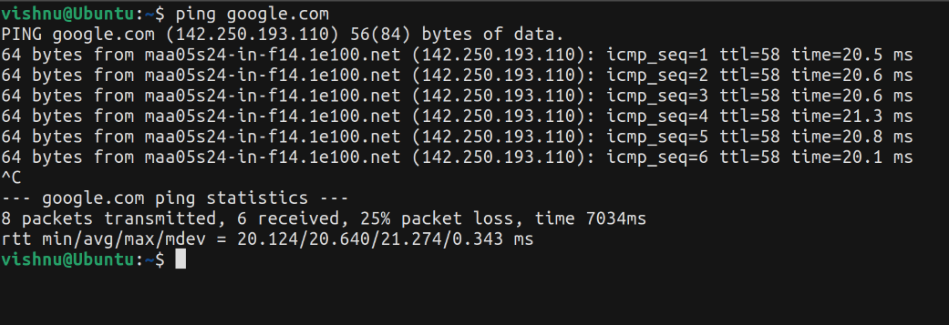

Route:

Command: route or netstat -r

The route command displays and manages the IP routing table on your device. It shows the network destinations and the corresponding gateway addresses used for routing network traffic.

Example: route print or netstat -r

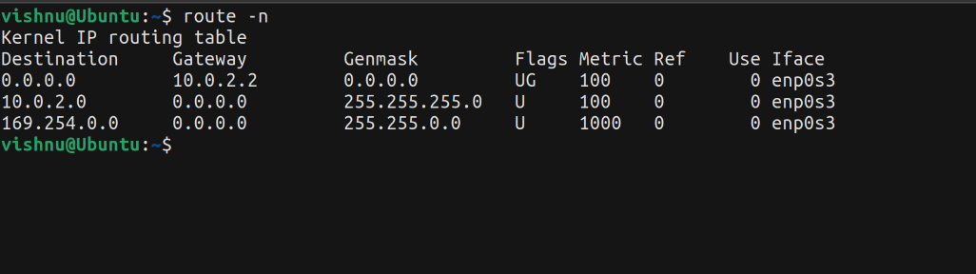

Traceroute:

Command: traceroute [destination]

The traceroute command helps identify the path that network packets take from your device to a specific destination. It displays the IP addresses of intermediate routers or hops along the route and measures the time it takes for packets to reach each hop.

Example: traceroute www.example.com or traceroute 192.168.1.1

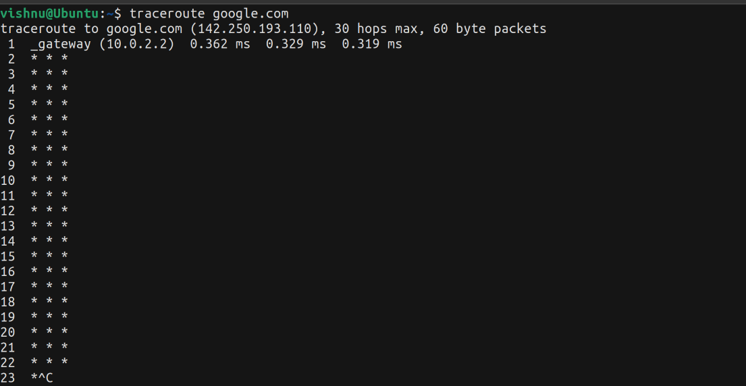

nslookup:

Command: nslookup [domain]

The nslookup command is used to query DNS (Domain Name System) servers to retrieve information about a specific domain. It can be used to find the IP address associated with a domain name or obtain other DNS-related information.

Example: nslookup www.example.com

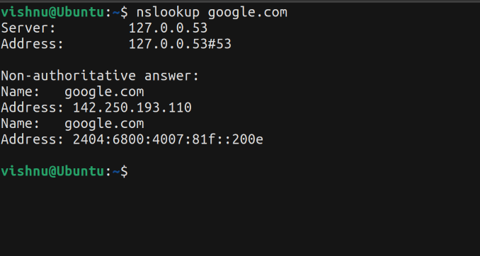

IP:

Command: ip [options] [command]

The ip command is a versatile networking tool available in Linux-based operating systems. It allows you to view and modify network interfaces, routing tables, and other network-related settings.

Example: ip address show to display IP addresses of network interfaces.

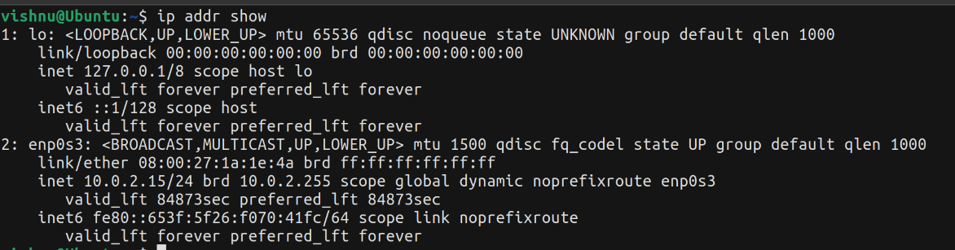

Setting up static and dynamic IP addresses:

Static IP Address:

In most operating systems, you can set up a static IP address by accessing the network settings or network configuration files. You'll need to provide the desired IP address, subnet mask, gateway address, and DNS server addresses manually.

Static IP addresses are typically used when you want a device to have a consistent, fixed IP address that doesn't change over time.

Dynamic IP Address (DHCP):

Dynamic IP addresses are assigned automatically using the DHCP (Dynamic Host Configuration Protocol) server on the network.

To configure dynamic IP addressing, you need to enable DHCP in your device's network settings. It will automatically obtain an IP address, subnet mask, gateway, and DNS server information from the DHCP server.

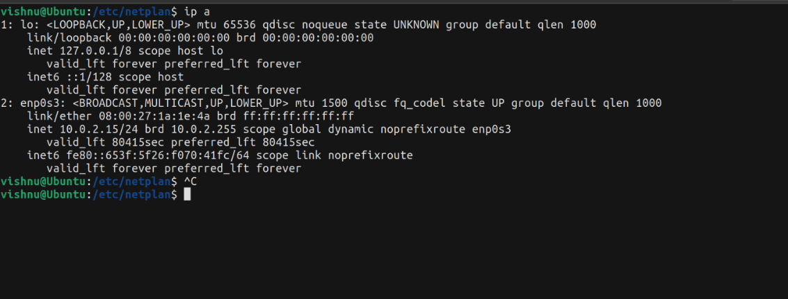

**Concept of Subnets**

In computer networking, a subnet refers to a logical subdivision of an IP network. It is a technique used to partition a single large network into smaller, more manageable networks called subnetworks or subnets. The purpose of subnetting is to improve network performance, enhance security, and simplify network administration.

Subnetting involves dividing an IP network into smaller network segments by manipulating the host portion of the IP address. An IP address consists of two parts: the network portion and the host portion. The network portion identifies the network to which a device belongs, while the host portion identifies the specific device within that network.

By using subnetting, you can allocate IP addresses more efficiently and group devices based on their requirements and purposes. Each subnet has its own unique network address, and devices within the same subnet share a common network prefix.

Subnetting also allows for more efficient use of network resources. For example, if you have a large network with thousands of devices, it may not be practical or efficient to broadcast network traffic to all devices. Subnetting enables you to divide the network into smaller segments, reducing the broadcast domain and limiting the scope of network traffic.

Moreover, subnetting enhances network security by creating isolated segments. Devices within the same subnet can communicate directly with each other, but communication between devices in different subnets requires routing. This isolation helps contain network issues, restrict unauthorized access, and minimize the impact of potential security breaches.

Subnets are identified by their subnet mask, which determines the network and host portions of an IP address. The subnet mask is represented using a series of ones (1) followed by a series of zeros (0). The ones indicate the network portion, while the zeros represent the host portion.

For example, in the IP address 192.168.0.0 with a subnet mask of 255.255.255.0, the first three octets (192.168.0) represent the network portion, and the last octet (0) represents the host portion. This subnet mask allows for 256 possible host addresses within the network.

Subnetting is commonly used in large networks, such as organizations, universities, and internet service providers (ISPs), to efficiently manage IP address allocation and optimize network performance.

**CIDR address schemes**

CIDR (Classless Inter-Domain Routing) is a method used for allocating IP addresses and routing Internet Protocol (IP) packets. It is an improved addressing scheme that replaces the older classful addressing scheme used in IPv4.

In CIDR, IP addresses are represented in a format that includes both the IP address and a prefix length, separated by a slash ("/") character. The prefix length indicates the number of bits in the IP address that are used as the network prefix. The remaining bits are used to identify hosts within the network.

CIDR allows for more flexible and efficient allocation of IP addresses by allowing variable-length subnet masks. This means that networks can be divided into smaller subnets, which reduces address wastage and allows for more efficient use of available IP addresses.

CIDR notation follows the format: <IP address>/<prefix length>. For example:

192.168.0.0/24 represents a network with an IP address of 192.168.0.0 and a prefix length of 24, indicating that the first 24 bits are used for the network prefix and the remaining 8 bits are available for host addresses. This corresponds to a subnet mask of 255.255.255.0.

10.0.0.0/16 represents a network with an IP address of 10.0.0.0 and a prefix length of 16, indicating that the first 16 bits are used for the network prefix and the remaining 16 bits are available for host addresses. This corresponds to a subnet mask of 255.255.0.0.

**Subnet masks**

A subnet mask is a 32-bit value used in conjunction with an IP address to determine the network and host portions of the address. It is used in IPv4 networks to divide an IP address into a network address and a host address. Subnet masks are typically represented in dotted decimal notation, similar to IP addresses.

In subnetting, the subnet mask contains a series of consecutive 1s followed by a series of consecutive 0s. The 1s represent the network portion of the address, and the 0s represent the host portion. The length of the consecutive 1s in the subnet mask is known as the prefix length or subnet prefix, which indicates the number of bits in the subnet mask that are used for the network portion.

For example, a subnet mask of 255.255.255.0 (or /24 in CIDR notation) has 24 consecutive 1s, representing the network portion, followed by 8 consecutive 0s for the host portion. This means that the first three octets of the IP address are used for the network, and the last octet is available for host addresses.

Subnet masks are used for various purposes, including:

1. Network addressing: They help identify the network portion of an IP address and determine which devices are on the same network.

2. Routing: Subnet masks are used by routers to determine the best path for forwarding IP packets.

3. Subnetting: Subnet masks are used to divide IP address ranges into smaller subnets for more efficient addressing and routing

**iptables**

In iptables, you can define rules based on IP addresses, including subnet addresses, to filter or manipulate network traffic. Here are a few examples of how you can use iptables with subnet addresses:

Allow incoming traffic from a specific subnet:

iptables -A INPUT -s 192.168.0.0/24 -j ACCEPT

This rule allows incoming traffic from the subnet 192.168.0.0/24. You can replace 192.168.0.0/24 with the desired subnet address.

Block incoming traffic from a specific subnet:

iptables -A INPUT -s 10.0.0.0/16 -j DROP

This rule blocks incoming traffic from the subnet 10.0.0.0/16. Adjust the subnet address as per your requirement.

Forward traffic from one subnet to another:

iptables -A FORWARD -s 192.168.1.0/24 -d 192.168.2.0/24 -j ACCEPT

This rule allows forwarding of traffic from subnet 192.168.1.0/24 to subnet 192.168.2.0/24. Make sure IP forwarding is enabled on your system for this to work.

Source NAT for a specific subnet:

iptables -t nat -A POSTROUTING -s 172.16.0.0/12 -o eth0 -j MASQUERADE

This rule performs source Network Address Translation (NAT) for the subnet 172.16.0.0/12 on the eth0 interface. Adjust the subnet and interface names accordingly.

These are just a few examples to illustrate how you can use iptables with subnet addresses. You can combine subnet addresses with other matching criteria like ports, protocols, or interface names to create more specific rules to suit your network security or routing requirements.

Remember to save your iptables rules and apply them persistently to ensure they survive system reboots. The exact method for saving and applying iptables rules may vary depending on your Linux distribution.

**Setting up a firewall for LAN**

To set up a firewall for a local area network (LAN), you can use iptables to define rules that control incoming and outgoing traffic between your LAN and the internet. Here's a basic approach to setting up a firewall for your LAN:

Define default policies:

Start by setting default policies for the INPUT, FORWARD, and OUTPUT chains to control how traffic is handled if no specific rules match. For example, you can set the default policy to DROP to deny all incoming and forwarded traffic unless explicitly allowed by rules.

iptables -P INPUT DROP

iptables -P FORWARD DROP

iptables -P OUTPUT ACCEPT

Allow LAN traffic:

Allow traffic within the LAN by permitting traffic from the LAN subnet on the INPUT and FORWARD chains. Adjust the subnet address based on your LAN's configuration.

iptables -A INPUT -s <LAN_subnet> -j ACCEPT

iptables -A FORWARD -s <LAN_subnet> -j ACCEPT

Allow specific incoming services:

If you need to allow specific services or ports to be accessible from the internet, such as HTTP (port 80) or SSH (port 22), you can add rules to permit incoming connections for those services.

iptables -A INPUT -p tcp --dport 80 -j ACCEPT # Allow incoming HTTP traffic

iptables -A INPUT -p tcp --dport 22 -j ACCEPT # Allow incoming SSH traffic

Be cautious when opening up ports to the internet and ensure that you understand the security implications.

Enable Network Address Translation (NAT):

If your LAN is using private IP addresses and requires internet access, you'll need to enable NAT to translate the private IP addresses to your public IP address when outgoing traffic goes to the internet. Here's an example:

iptables -t nat -A POSTROUTING -s <LAN_subnet> -o <internet_interface> -j MASQUERADE

Replace <LAN_subnet> with your LAN's subnet and <internet_interface> with the network interface connected to the internet (e.g., eth0).

Save and apply rules:

Once you have defined your firewall rules, save them to a file and apply them on system startup or when necessary. The process for saving and applying rules may differ based on your Linux distribution. For example, on Ubuntu, you can use the iptables-persistent package to save and restore rules automatically.

# Save rules to a file

iptables-save > /etc/iptables/rules.v4

# Apply rules on system startup

iptables-restore < /etc/iptables/rules.v4

**Application layer (L7) proxies**

Application layer (Layer 7) proxies are network devices or software applications that operate at the highest layer of the OSI model, the application layer. These proxies are designed to handle and manage network traffic based on application-specific protocols and perform various functions such as load balancing, caching, content filtering, and security enforcement. They provide an additional layer of control and visibility over network traffic flowing between clients and servers.

Here are some key features and use cases of Layer 7 proxies:

1. Load balancing: Layer 7 proxies distribute incoming client requests across multiple backend servers based on advanced criteria such as URL, session information, or content type. This helps evenly distribute the workload and improve application performance and scalability.

2. Caching: Proxies can cache frequently accessed content from backend servers, reducing the response time and network bandwidth usage. By serving cached content, they can offload requests from the backend servers and improve overall system performance.

3. SSL/TLS termination: Layer 7 proxies can handle SSL/TLS encryption and decryption, relieving the backend servers from the computational overhead of cryptographic operations. This enables secure communication between clients and servers while offloading the SSL/TLS processing to the proxy.

4. Content filtering and security: Proxies can inspect and filter network traffic based on application-layer attributes, allowing for the enforcement of security policies, content filtering, or access control rules. They can block or allow traffic based on URL, file type, keywords, or other application-specific criteria.

5. Protocol transformation: Layer 7 proxies can translate or transform network protocols to bridge communication gaps between clients and servers that use different protocols or versions. For example, they can convert between HTTP and HTTPS, perform protocol conversions for backend applications, or even bridge different application protocols.

6. Application acceleration: Proxies can optimize and accelerate application performance by implementing techniques such as compression, protocol optimization, and connection pooling. These optimizations reduce bandwidth usage, minimize latency, and improve user experience.

7. API gateway: Layer 7 proxies can act as API gateways, providing a centralized entry point for accessing and managing APIs. They can handle API authentication, rate limiting, request/response transformations, and traffic analytics.

Popular Layer 7 proxy solutions include Nginx, HAProxy, Apache Traffic Server, and Envoy. These proxies can be deployed as standalone devices, virtual appliances, or as software applications running on dedicated servers or in cloud environments.

Layer 7 proxies provide granular control and advanced functionality for managing and securing network traffic at the application layer, making them essential components in modern network architectures.

**Result:**

Familiarisation done successfully.

**LAB CYCLE:5**

**EXPERIMENT NO:8**

**Date:**

**Aim:** Network & Packet Analysis

Analyzing network packet stream using tcpdump and wireshark. service tests using nc.

Network and packet analysis are fundamental techniques used in computer networking and cybersecurity to examine and understand the behavior and communication patterns of networked devices. This analysis provides insights into how data flows across a network, identifies potential issues, and helps in diagnosing and troubleshooting network problems. Here's an overview of network and packet analysis:

**Network Analysis:**

Network analysis involves studying the overall behavior, performance, and health of a network. This can include examining factors such as network traffic, latency, bandwidth utilization, and response times. Network analysis tools and techniques help network administrators and engineers ensure that the network is functioning optimally and identify any anomalies or bottlenecks.

**Packet Analysis:**

Packet analysis is a more granular approach that involves inspecting individual packets of data that travel across a network. Each packet contains information about the source, destination, payload, and other relevant metadata. Packet analysis helps in understanding the details of network communication, diagnosing issues, and detecting potential security threats.

**Key Concepts in Packet Analysis:**

* Packets: Data sent over a network is divided into packets, which are small units of data that include headers (containing routing information) and payloads (actual data being transmitted).
* Protocols: Networks use communication protocols (such as TCP, UDP, HTTP, etc.) to define how data is formatted, transmitted, and received. Analyzing protocols helps in understanding how different devices communicate.
* Capture: To perform packet analysis, you need to capture network traffic using tools like Wireshark, tcpdump, or Microsoft Network Monitor. These tools capture packets in real-time or from packet capture files.
* Inspection: Once packets are captured, analysts can inspect individual packets to gather information about the communication. This includes examining header details, payload contents, and timing information.
* Filters and Display Filters: Packet analysis tools allow you to filter and focus on specific packets of interest based on criteria like source IP, destination port, protocol, etc. This is helpful for narrowing down the analysis to relevant packets.
* Anomalies and Patterns: Analysts look for anomalies in packet behavior, such as unusually high traffic volume, unusual communication patterns, or unexpected packet types. These anomalies can indicate network issues or potential security breaches.
* Troubleshooting: Packet analysis is invaluable for diagnosing network problems. By examining packets, analysts can identify issues like latency, dropped packets, misconfigurations, and more.
* Security Analysis: Packet analysis is a crucial tool for detecting security threats like intrusion attempts, malware infections, data breaches, and more. Security analysts can identify patterns that indicate unauthorized or suspicious activity.

**Challenges:**

* Complexity: Network traffic can be vast and complex, making it challenging to analyze all packets effectively.
* Encryption: Encrypted traffic makes it difficult to inspect packet contents. While headers can still provide useful information, payload analysis is limited.
* Packet Overload: High network traffic can lead to a massive volume of captured packets, requiring effective filtering and analysis techniques.
* False Positives: Identifying genuine threats among a large volume of packets can be challenging, as false positives can waste time and resources.

Both network and packet analysis play a crucial role in maintaining network performance, ensuring security, and troubleshooting issues in complex network environments.

Analyzing network packet stream using tcpdump and wireshark. service tests using nc.

1. tcpdump:

tcpdump is a command-line packet analyzer that allows you to capture and display network packets flowing through a network interface. It's often used for diagnosing network issues, analyzing network traffic, and debugging network protocols. Here's a basic command to capture packets on a specific interface:

sudo tcpdump -i eth0 -n -s 0 -w capture.pcap

-i eth0: Specifies the network interface to capture packets from.

-n: Displays numerical addresses instead of resolving hostnames.

-s 0: Captures the entire packet.

-w capture.pcap: Writes the captured packets to a file in pcap format.

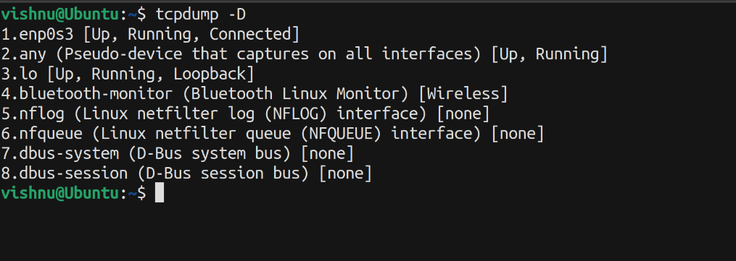

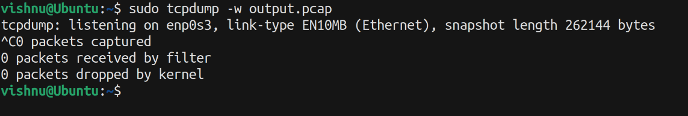

2. Wireshark:

Wireshark is a popular open-source network protocol analyzer used for network analysis, troubleshooting, and packet capturing. It allows network administrators, security professionals, and developers to capture and inspect the packets that flow over a computer network.

1. Packet Capture: Wireshark captures network packets from the network interface or from a saved packet capture file. It can capture packets from various sources, including wired and wireless connections.
2. Packet Inspection: Once packets are captured, Wireshark displays them in a graphical interface, providing a detailed view of the packet contents. It can dissect and interpret a wide range of network protocols, from common ones like TCP, UDP, and HTTP to more specialized protocols used in various applications.
3. Protocol Analysis: Wireshark can help in analyzing protocol behaviors and interactions. By examining the sequence of packets and their content, network analysts can identify issues such as misconfigurations, performance bottlenecks, or security vulnerabilities.
4. Troubleshooting: When network issues arise, Wireshark can assist in diagnosing the problem by showing the actual data being transmitted. It can help identify issues like dropped packets, high latency, incorrect protocol usage, or unexpected traffic patterns.
5. Security Analysis: Wireshark is also valuable for security professionals in detecting malicious activities or potential breaches. It allows for the inspection of network traffic to identify signs of unauthorized access, data exfiltration, or other suspicious behaviors.
6. Performance Optimization: Wireshark can help in optimizing network performance by analyzing the flow of data. By examining packet delays, retransmissions, and other performance metrics, network engineers can identify areas where improvements can be made.
7. Baseline Creation: Network administrators often use Wireshark to establish baselines for network behavior. This involves capturing and analyzing normal network traffic patterns, which can then be used for comparison when troubleshooting abnormal behavior.
8. Protocol Development and Testing: Developers use Wireshark to validate their protocol implementations. By examining how their software communicates over the network, they can ensure that their protocols adhere to specifications and standards.
9. Educational Purposes: Wireshark is widely used in educational settings to teach networking concepts, protocols, and network analysis techniques. Students can gain hands-on experience by capturing and analyzing real network traffic.

3. Netcat (nc):

netcat (often referred to as nc) is a versatile networking utility that can be used for various tasks, including creating network connections, transferring data, and performing service tests. For service testing, you can use it to send and receive data to check the availability of a specific service on a target host.

Here's an example:

To test a TCP service on a specific host and port:

nc <host> <port>

To test a UDP service:

echo "Test data" | nc -u -w1 <host> <port>

-u: Use UDP instead of the default TCP.

-w1: Set a timeout of 1 second.

Remember to replace <host> and <port> with the actual target host and port.

# Result:

Familiarized with network packet stream analysis conducted using tcpdump and Wireshark.

**LAB CYCLE:6**

**EXPERIMENT NO:9**

**Date:**

**Aim:** Setting up the LAMP Stack.

Illustrate the steps involved in installing the LAMP Stack on a Linux machine. Deploy phpMyadmin.

**Steps to install LAMP Stack:**

A “LAMP” stack is a group of open-source software that is typically installed together to enable a server to host dynamic websites and web apps. This term is actually an acronym which represents the Linux operating system, with the Apache web server. The site data is stored in a MySQL database, and dynamic content is processed by PHP.

**Step 1:** Installing Apache and Updating the Firewall

**Command:** sudo apt update

Once the cache has been updated, you can install Apache:

**Command:** sudo apt install apache2

After entering this command, apt will tell you which packages it plans to install and how much extra disk space they’ll take up. Press Y and hit ENTER to confirm, and the installation will proceed.

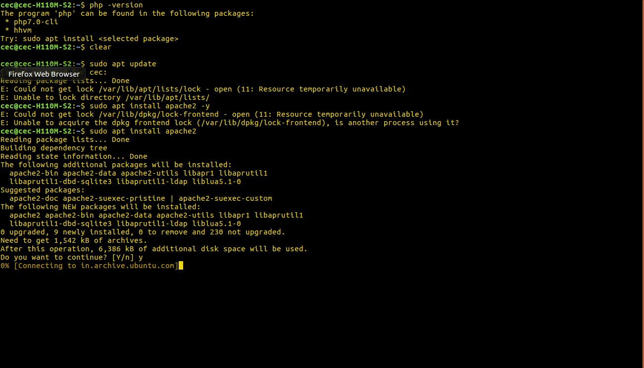

To know the active status of apache server:

**Command:** sudo service apache2 status

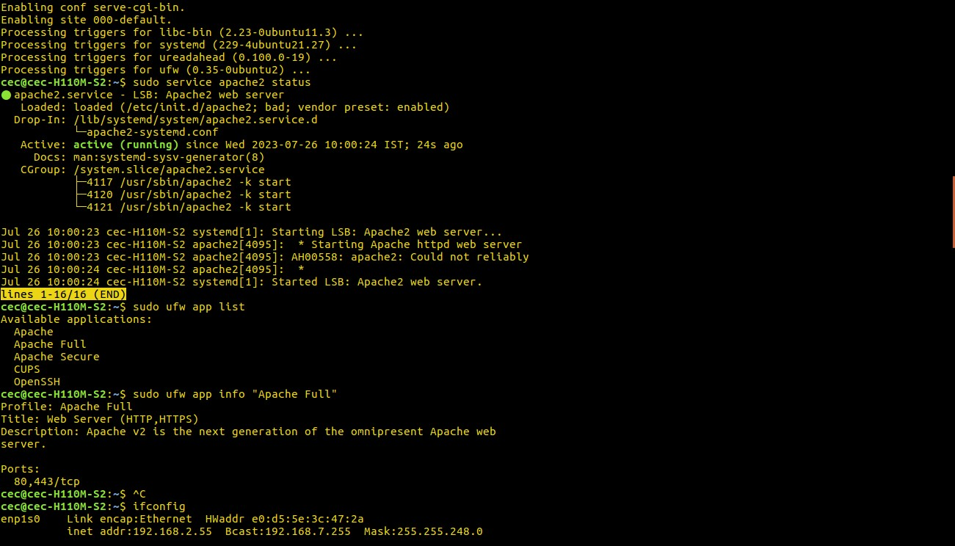

Adjust the Firewall to Allow Web Traffic

Make sure that your firewall allows HTTP and HTTPS traffic. You can check that UFW has an application profile for Apache like so:

**Command:** sudo ufw app list

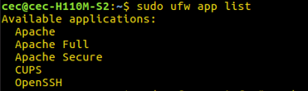

If you look at the Apache Full profile details, you’ll see that it enables traffic to ports 80 and 443:

**Command:** sudo ufw app info "Apache Full"

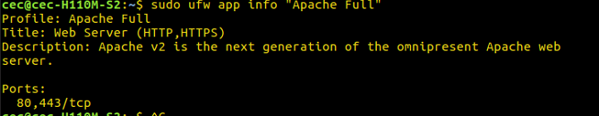

To allow incoming HTTP and HTTPS traffic for this server, run:

**Command:** sudo ufw allow "Apache Full"

You can do a spot check right away to verify that everything went as planned by visiting your server’s public IP address in your web browser.

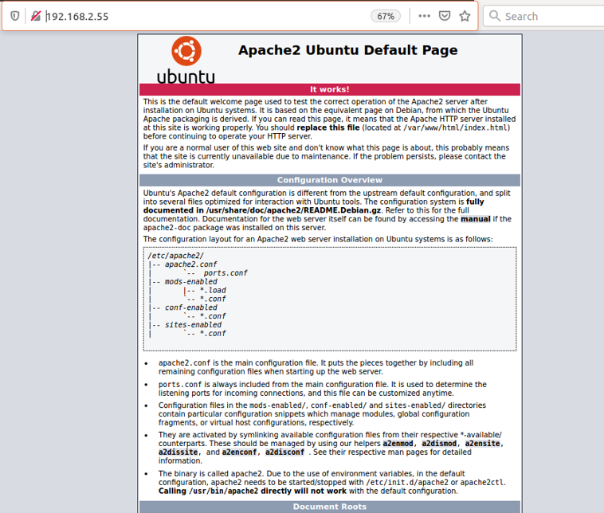

**Step 2:** **Installing MySQL**

MySQL is a database management system. Basically, it will organize and provide access to databases where your site can store information.

**Command:** sudo apt install mysql-server

Enter Y to continue.

When the installation is complete, run a simple security script that comes pre-installed with MySQL which will remove some dangerous defaults and lock down access to your database system. Start the interactive script by running:

**Command:** sudo mysql_secure_installation

**Command:** sudo mysql

**Step 3:** Installing PHP

PHP is the component of your setup that will process code to display dynamic content. It can run scripts, connect to your MySQL databases to get information, and hand the processed content over to your web server so that it can display the results to your visitors.

Once again, leverage the apt system to install PHP. In addition to the php package, you’ll also need libapache2-mod-php to integrate PHP into Apache, and the php-mysql package to allow PHP to connect to MySQL databases. Run the following command to install all three packages and their dependencies:

**Command:** sudo apt install php libapache2-mod-php php-mysql

Changing Apache’s Directory Index (Optional)

**Command:** sudo nano /etc/apache2/mods-enabled/dir.conf

After this, restart the Apache web server in order for your changes to be recognized. You can do that with the following command:

**Command:** sudo systemctl restart apache2

check on the status of the apache2 service using systemctl:

**Command:** sudo systemctl status apache2

**Installing PHP Extensions**

To extend the functionality of PHP, you have the option to install some additional modules. To see the available options for PHP modules and libraries, pipe the results of apt search into less, a pager which lets you scroll through the output of other commands:

**Command:** apt search php- | less

**Step4:** Testing PHP Processing on your Web Server

In order to test that your system is properly configured for PHP, create a PHP script called info.php. In order for Apache to find this file and serve it correctly, it must be saved to your web root directory.

Create the file at the web root you created in the previous step by running:

**Command:** sudo nano /var/www/your_domain/info.php

This will open a blank file. Add the following text, which is valid PHP code:

When you are finished, save and close the file.